**Pizza Connection**  
**User manual**

**Mattew Krol | William Esparza | Mehedi Zihad | Kanta Islam**

**Advised by**

**GTA Saeed Bhakhshan**

**Professor Seyed Ziae Mousavi Mojab**

Table of Contents

1. Introduction 2

1.1 Overview 2

1.2 Target Audience 4

2.Getting Started 4

2.1 System Requirements 4

2.2 System Setup 4

Features 6

3.1 Home Page 6

3.1.1 Navigating the Home Page 6

3.1.2 Quick Access Features 7

3.2 Sign Up 10

3.2.1 Creating a New Account 10

3.3 Login 11

3.3.1 Accessing the Login Page 11

3.4 User Profile 12

3.4.1 Editing Profile Information 12

3.5 Forgot Password 12

3.5.1 Account Recovery Process 13

3.5.2 Resetting Password 14

3.6 Add Employees 14

3.7 Manage Employees 15

3.7.1. Edit Employee 15

3.7.2 Search Employee 16

3.7.3 Filter by Roles 16

3.7.3 Delete Employee: 16

3.7.4 Time Sheet: 17

3.8 Employee Time Clock 17

3.8.1 Clock In 18

3.8.2 Clock Out 18

3.8.3 Pay Period selection & Work Hours view 19

3.9 Time Sheet Management 21

3.9.1 Edit Time Entry: 22

3.9.2 Delete Time Entry: 22

3.9.3 Filter by Week: 22

3.9.4 Download Filtered Weekly report: 23

3.10 Pizza Menu 23

3.10.1 Browsing the Menu 24

3.11 Order Cart 24

3.11.1 Managing Cart Contents 24

You can also change some selection on items in the cart. To do this hit the edit button, and the changeable options will appear on the right side of the screen. 25

3.11.2 Place order 25

3.12 Inventory 25

3.12.1 Adding Inventory Items 26

3.12.2 Inventory Editing 27

3.12.3 Inventory Tracking 27

3.13 Payment 29

3.14 Order List 31

3.14.1 Search Order: 32

3.14.2 Filter order: 32

3.14.3 Filter Order Status: 33

3.14.4 Sorting Email: 33

3.14.5 Sorting Date & Time: 33

3.14.6 Sorting Date & Time: 34

3.14.7 Display Items Details: 34

3.15 Contact Us 34

3.16 About Us 35

# **1. Introduction**

## 1.1 Overview

Pizza Connection is a user-friendly web app designed to meet the needs of everyone in the pizza business – customers, employees, and managers. We focus on making things efficient and easy, with a bunch of features that are carefully made to improve the experience for everyone involved.

**General Features:**

The following describes features that everyone can use.

* **Homepage:** A warm and inviting interface featuring key information and promotions, leaving a positive initial impression.
* **Sign Up:** User-friendly registration functionality for onboarding new users into the system.
* **Sidebar:** An easily navigable panel for quick access to different sections of the application.
* **Contact Us & About Us:** Informational pages offering contact details, an inquiry form, and insights into the company's history and values.
* **Website UI and Responsiveness:** A visually appealing and responsive design ensuring a seamless user experience across various devices.
* **Pizza Menu:** An intricately detailed presentation of available pizzas with enticing descriptions, simplifying the ordering process.
* **Order Cart:** An intuitive shopping cart, allowing customers to effortlessly review and modify their orders.
* **Sign Up:** User-friendly registration functionality for onboarding new users into the system.
* **Log in :** Customer can log in their created account.

Users gain access to specific features based on their individual credentials. Anyone can create an account as a customer. However, to access the website as an employee or manager, you'll need credentials from the admin.

**Customer-Centric Features:**

These features are designed specifically for customers.

* **Order Cart:** An intuitive shopping cart, allowing customers to effortlessly review and modify their orders.
* **Payment:** Seamless integration of a secure payment gateway for safe and efficient online transactions.
* **Order Confirmation:** A comprehensive confirmation page displaying order details and transaction summaries.

**Employee Features:**

GeThese features are designed specifically for employees.

* **Profile:** Personalized profiles for employees, contributing to an organized and efficient workforce management system.
* **Time Clock In & Clock Out:** A feature-rich time management system incorporating pay period tracking, real-time entries, and downloadable working hours PDFs.

**Manager Features:**

These features are designed specifically for managers

* **Manage Employees:** Robust tools empowering owners and managers to search, filter (by role), edit, and delete employee profiles.
* **Timesheet Management:** Comprehensive control over time clock entries, including functionalities for adding, editing, and deleting, with weekly hour filtering and report downloads.
* **Order Tracking:** The manager can monitor orders using sales tracking, gaining insight into the actual scenario of the business.
* **Inventory Management:** This includes inventory view, adding, editing and tracking. This allows the owner/manager to keep their inventory in one place where they can easily access it and update it without having to manually keep track of their inventory on paper. The manager/owner can know at any time what they have and how much of it they have as well as know when any item was and how much of that item was used up or added for a particular day (opening or closing shift).

**Common feature for Employee and manager:**

The employee and manager, both can access the following feature

* **Order List:** Efficient search options based on customer email, order type (pick-up/delivery), and status, complemented by sorting capabilities based on date and time.
* **Inventory Management:** Robust features facilitating the addition, editing, viewing, and tracking of inventory, ensuring effective control and optimization.

## 1.2 Target Audience

**Pizza Businesses:**

* **Owners and Managers:** Individuals responsible for overseeing the daily operations, employee management, and financial aspects of a pizza industry establishment.

**Customers:**

* **Pizza Enthusiasts:** Individuals who enjoy ordering and experiencing a variety of pizzas with a preference for a seamless and user-friendly online ordering process.

**Employees:**

* **Employees of Pizza Business:** Individuals employed in various roles within a pizza establishment, benefiting from streamlined time management, efficient communication, and a user-friendly work environment.

**Pizza Industry Entrepreneurs:**

* **Entrepreneurs Considering Pizza Business:** Individuals exploring opportunities in the pizza industry, seeking a comprehensive and efficient platform to manage their business.

# **2.Getting Started**

## 2.1 System Requirements

To get started with this program there are some requirements before you can use it.

Git: you can get it here https://git-scm.com/download/win

Node version 20.10.0: You can get it here https:://node.js.org/en/download/

In PowerShell `git clone https://github.com/EternalBlue14/CSC4996PizzaApp.git` into your documents.

## 2.2 System Setup

Step-1: First need to open “pizza app” in any Code editor or terminal.

Step-2: Go to frontend directory using command “cd frontend” from “pizza app” directory

**Step-3:** **“npm install”**

Install npm from frontend directory using commnad “npm install”

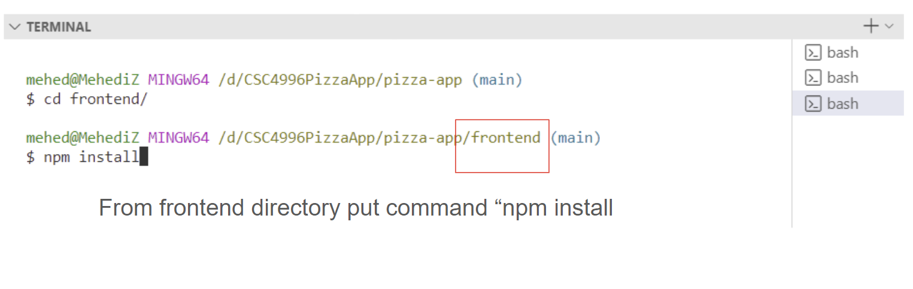

**Step –4: “npm run dev”**

In the backend use 'npm run dev' command from backend directory. It will connected the database and automatically run the app in your default browser.

Runs the app in the development mode.\

Open [http://localhost:3000](http://localhost:3000) to view it in your browser.

The page will reload when you make changes.\

**Final Step:**

After running “npm run dev” database will connect. Ans server will start in your default browser. Or You can use “ localhost:3000” in your default browser.

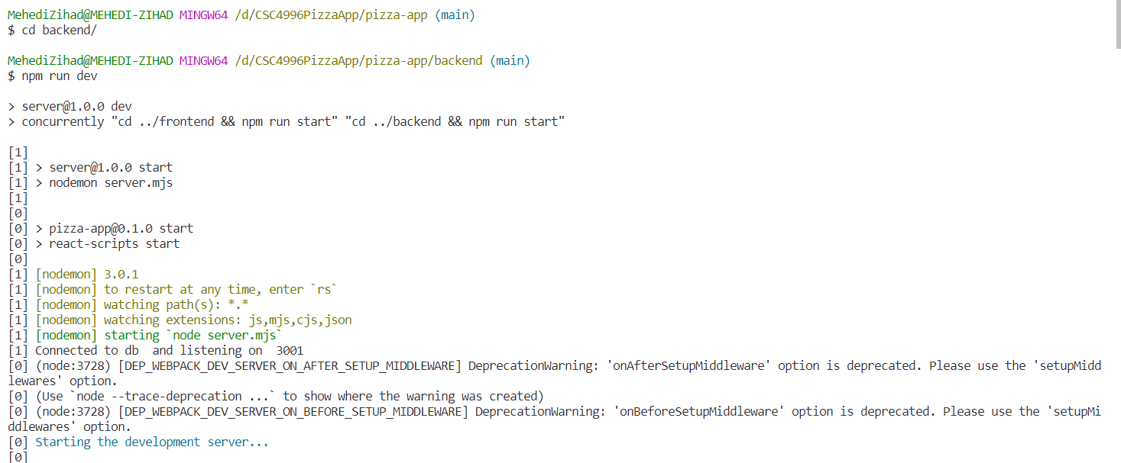

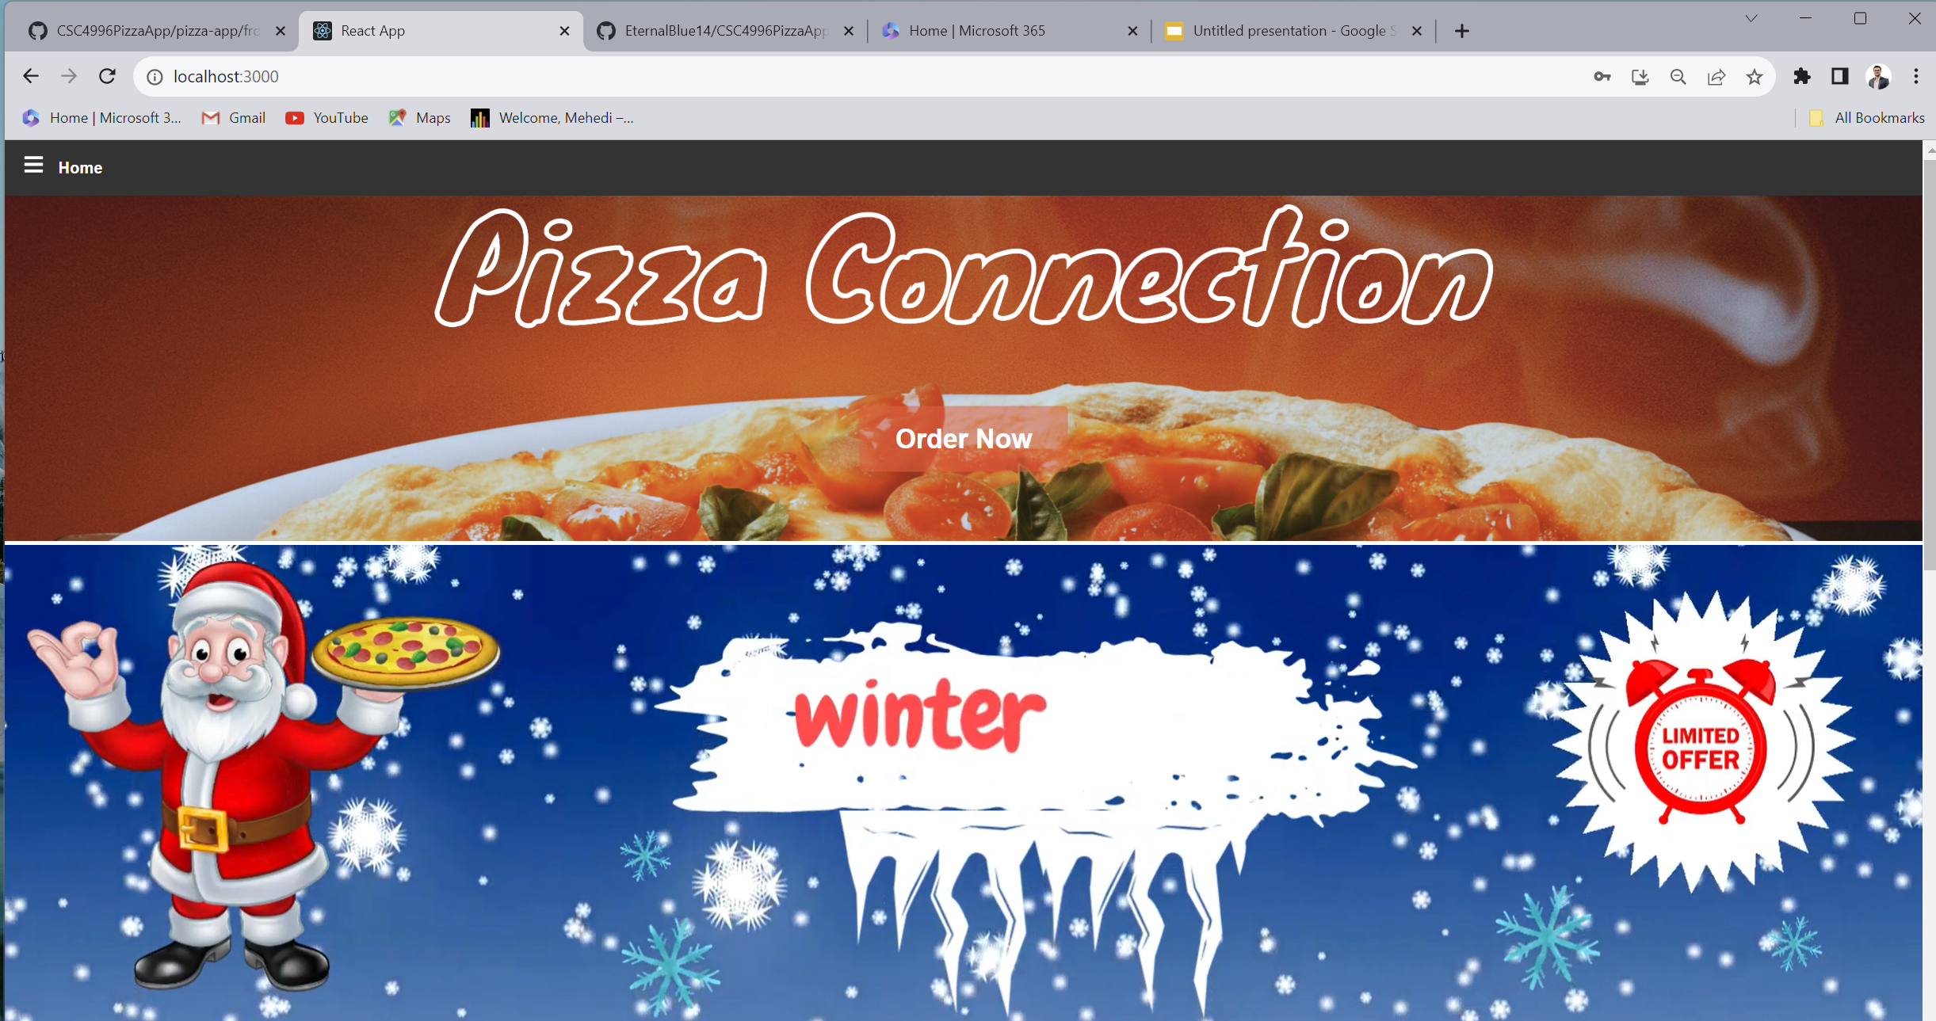

# **Features**

## **3.1 Home Page**

### 3.1.1 Navigating the Home Page

General overview of homepage

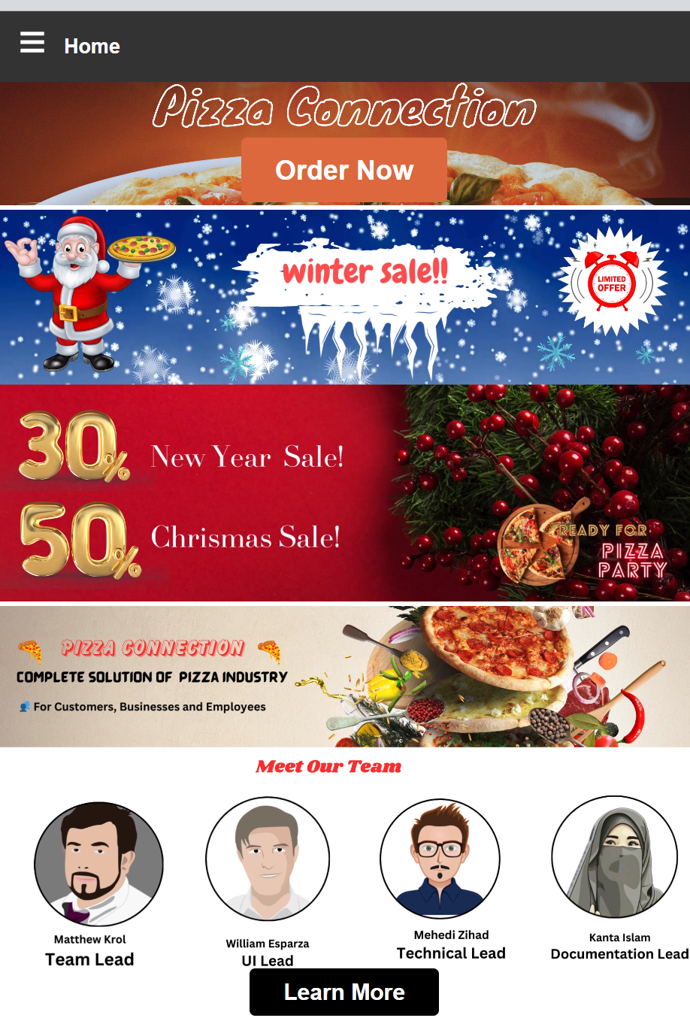

### 3.1.2 Quick Access Features

On the home page you can found the “order now” easy access of pizza menu from home page

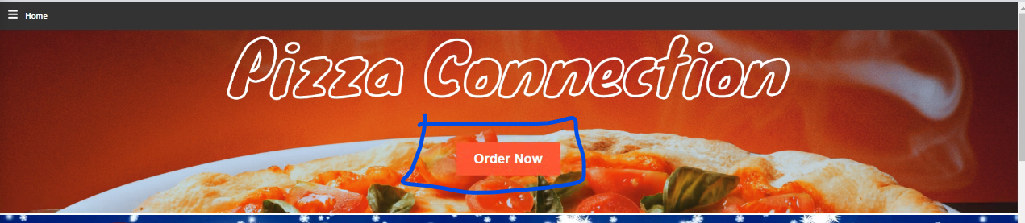

After clicking the order now redirection of pizza menu

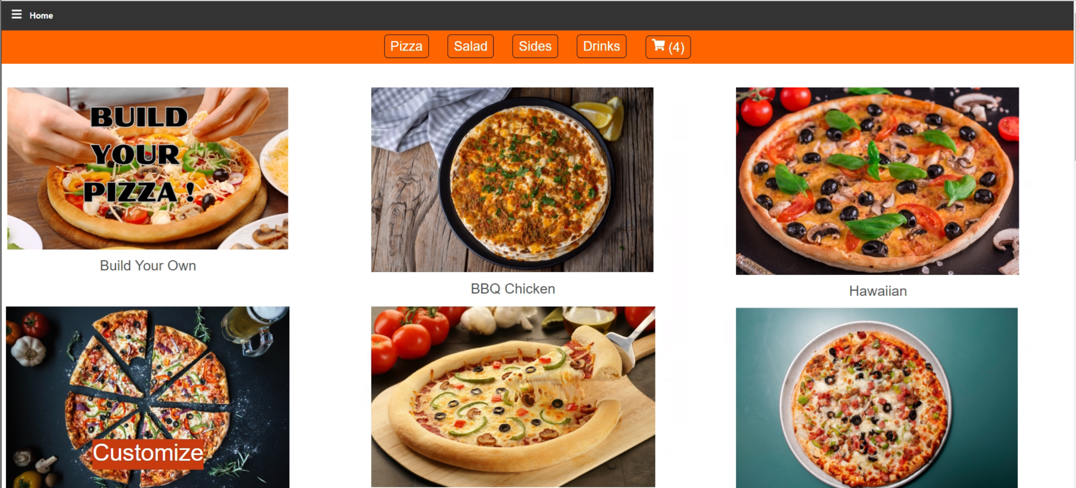

General User Sidebar View :

This is the sidebar view for with out log in or in general

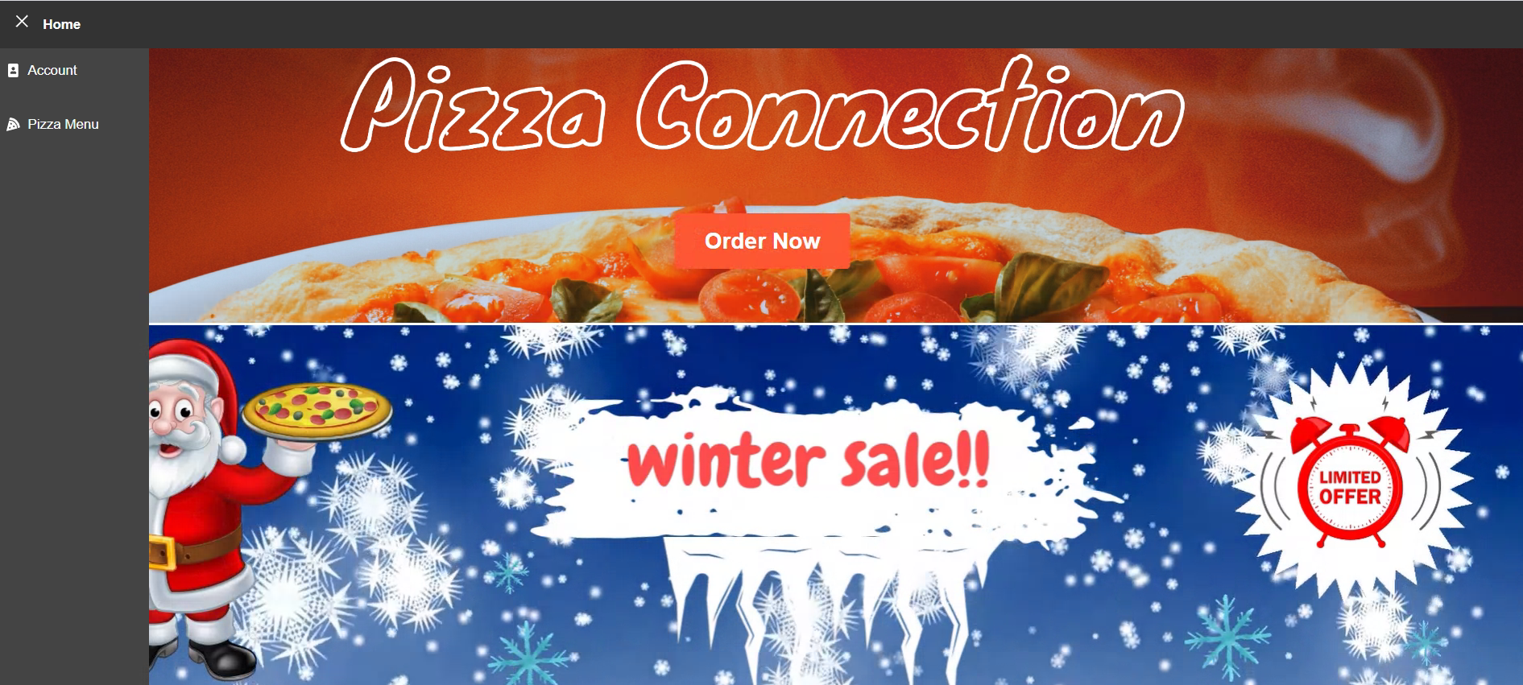

Customer User Sidebar View :

Customer can access the pizza menu , profile and logout after log in as customer using the sidebar .

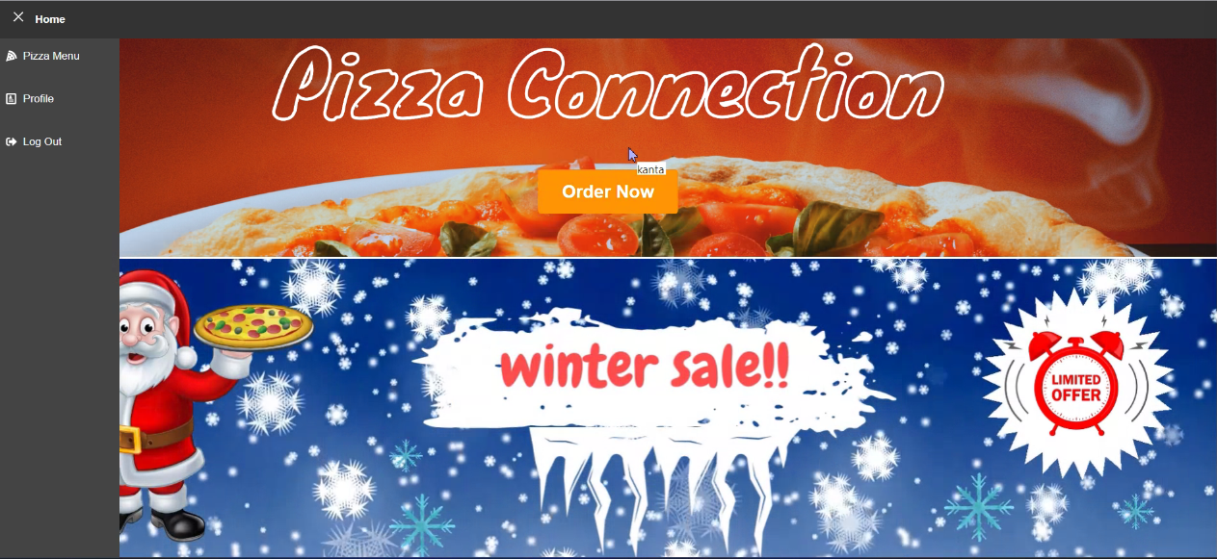

Employee User Sidebar View :

Employee can access the pizza menu , manage inventory , order list, profile, Log out .

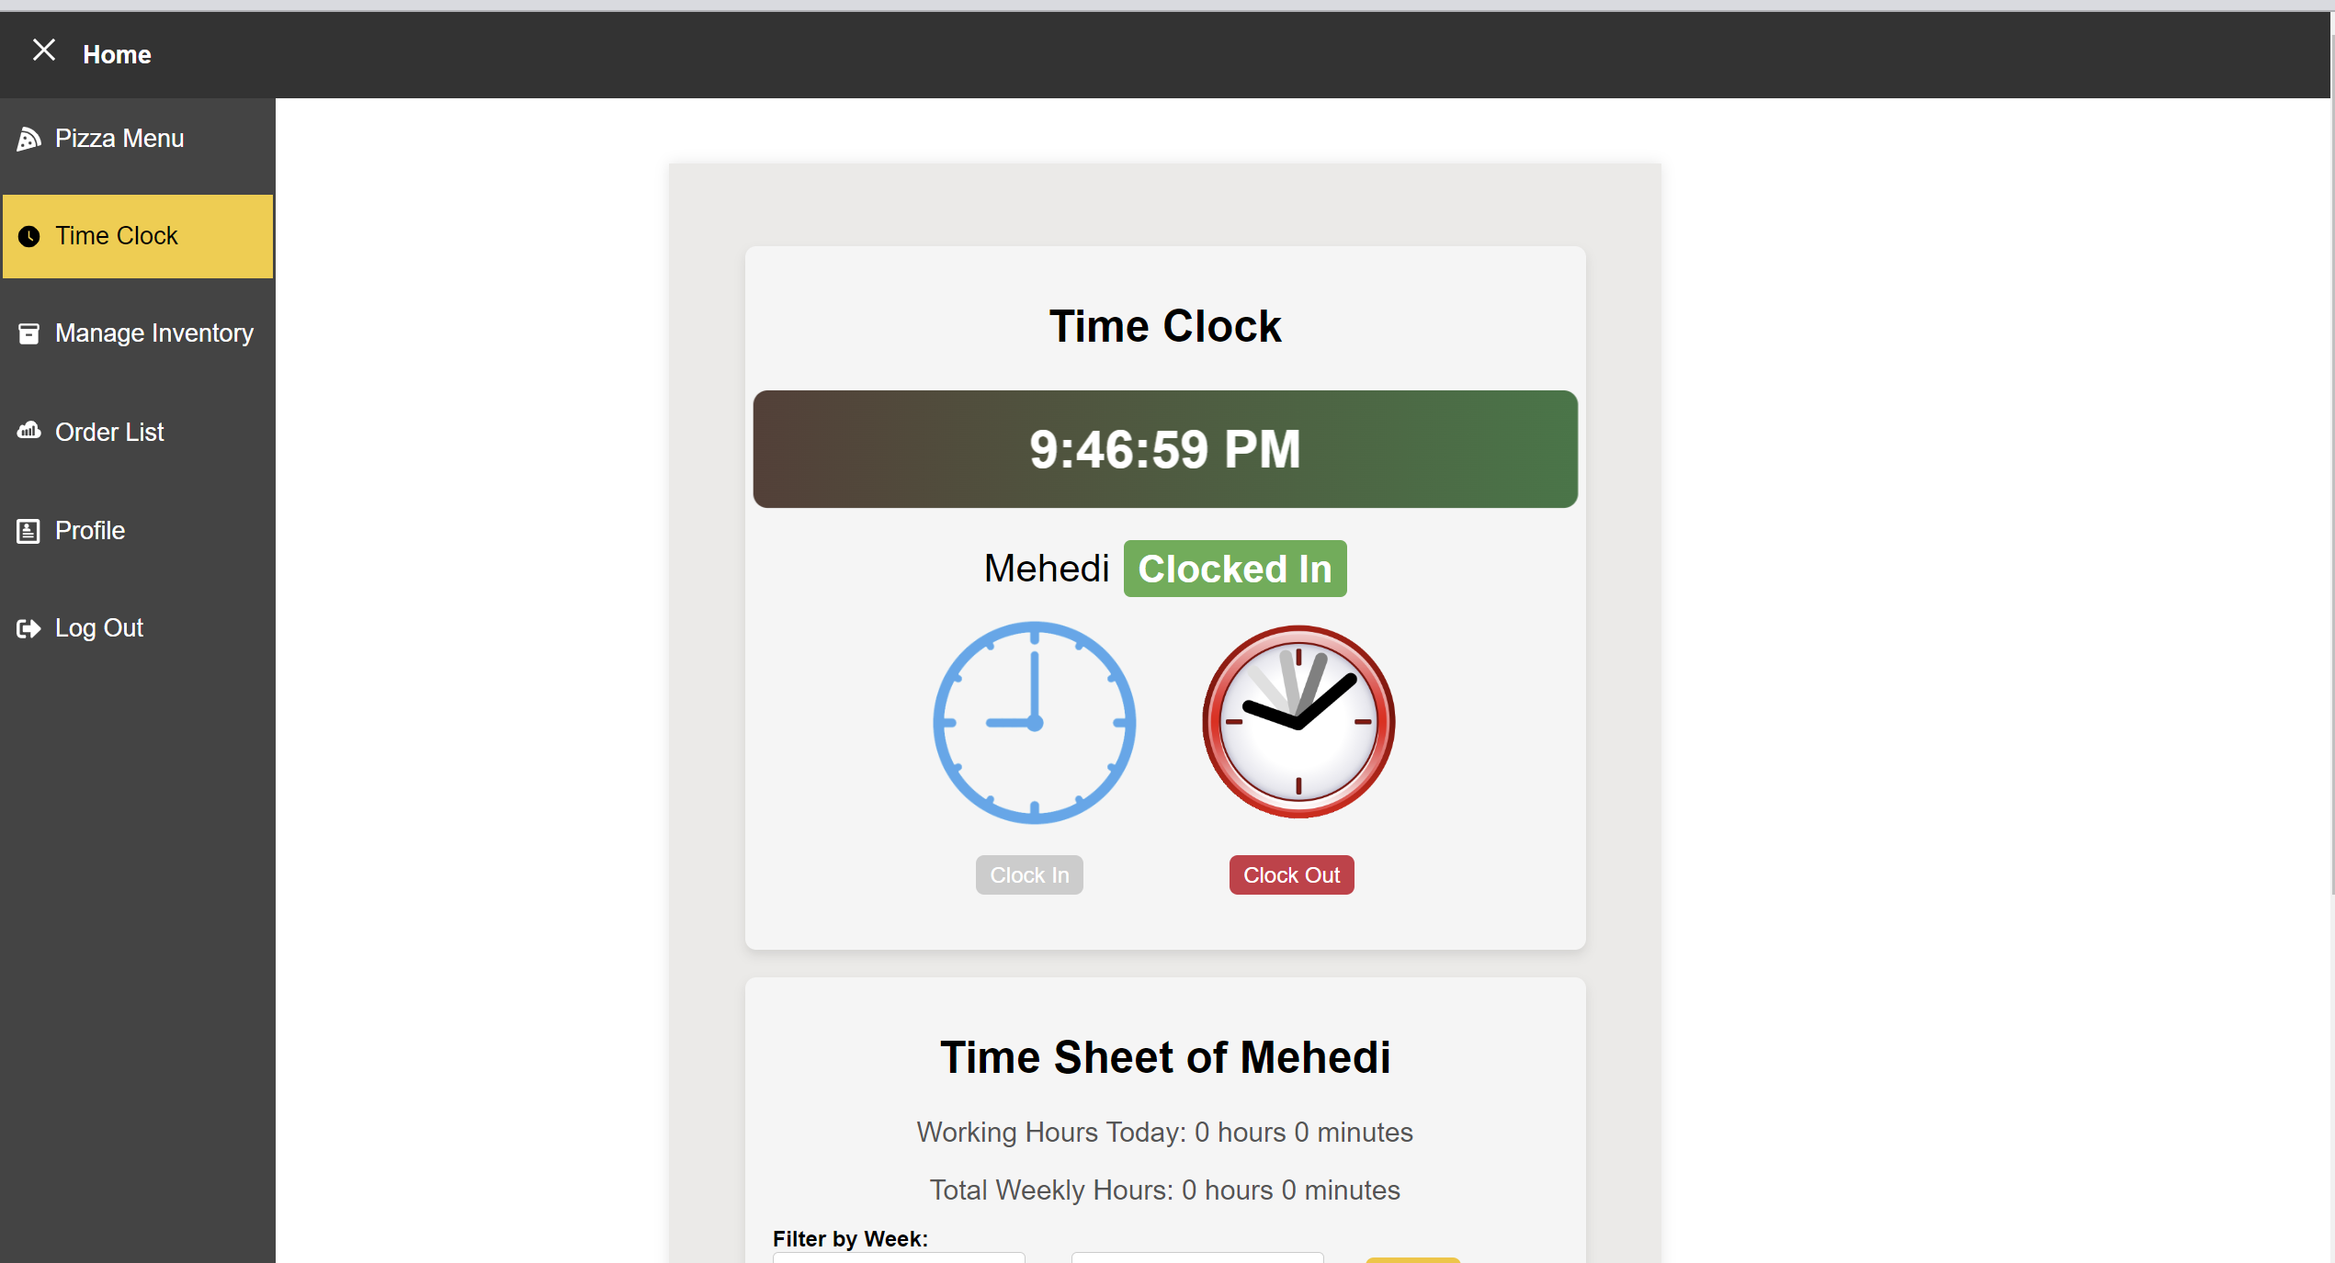

Manager User Sidebar View:

Manager can access Manage Employees , Add employees, Manage Inventory , Time clock , Order List , Profile and Logout by using the sidebar.

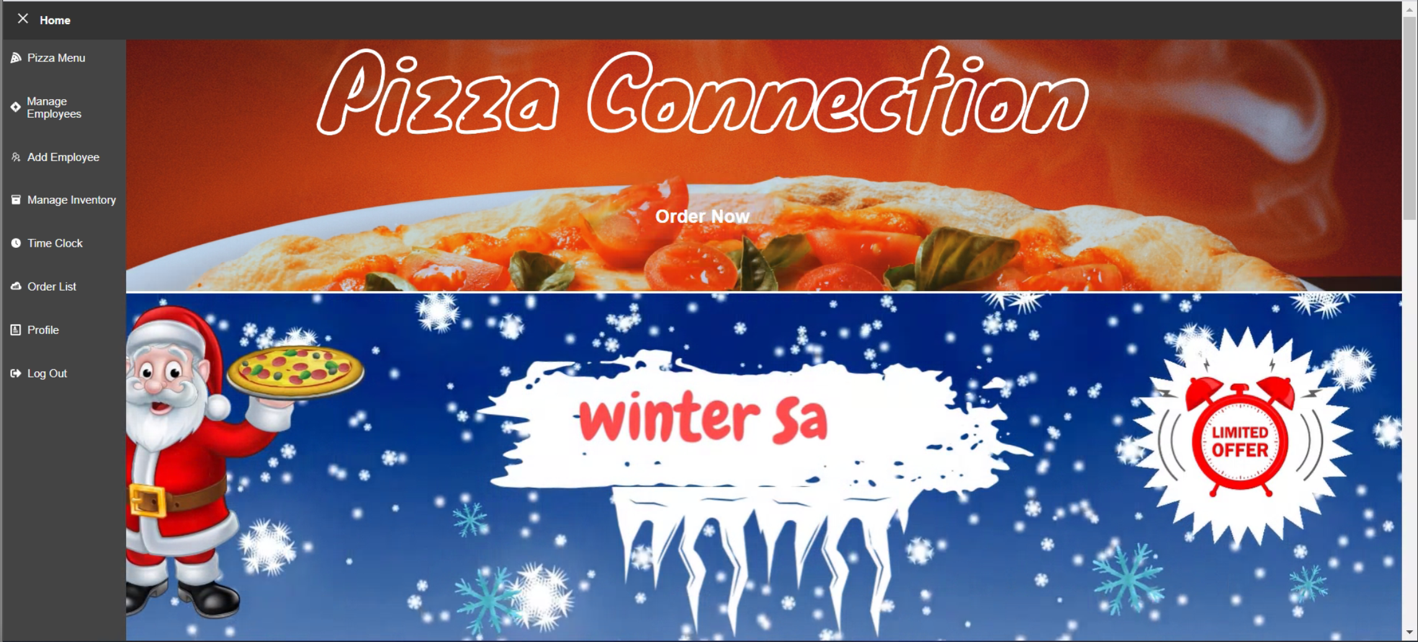

## **3.2 Sign Up**

### 3.2.1 Creating a New Account

User can create the account by the inputting the email address and password. User needs to create the password follow

The Password Criteria

Include at least 1 uppercase letter

Include at least 1 lowercase letter

Include at least 1 number

Include at least 1 special character

Be at least 8 characters long

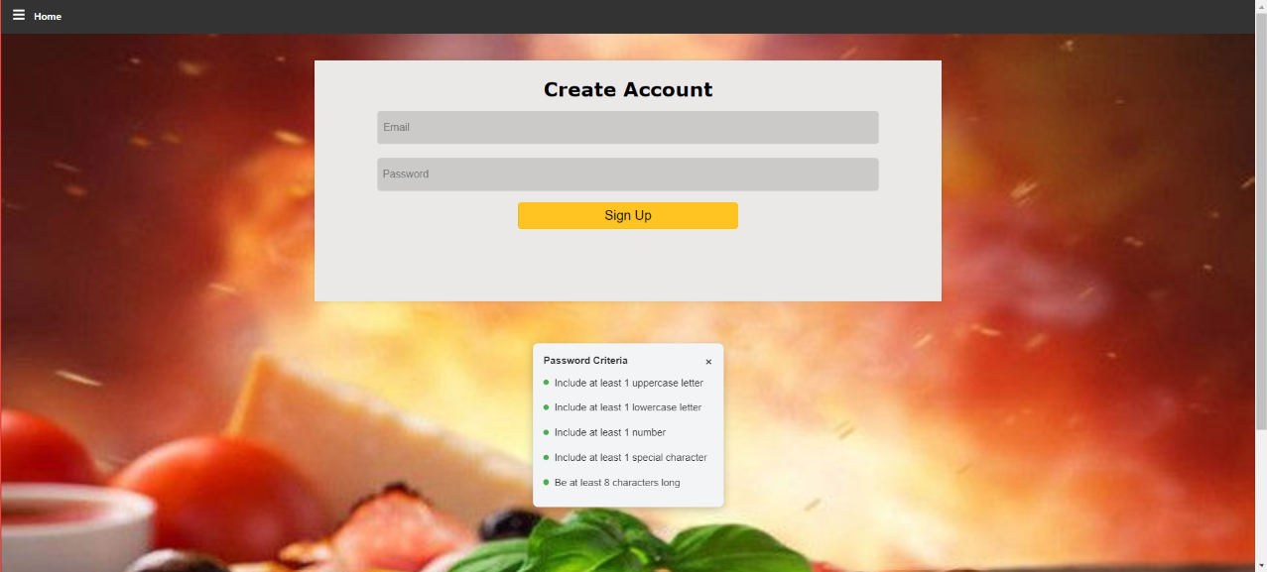

## **3.3 Login**

To log in, enter a valid username and password you have signed up with. After entering that data, you click on the login button.

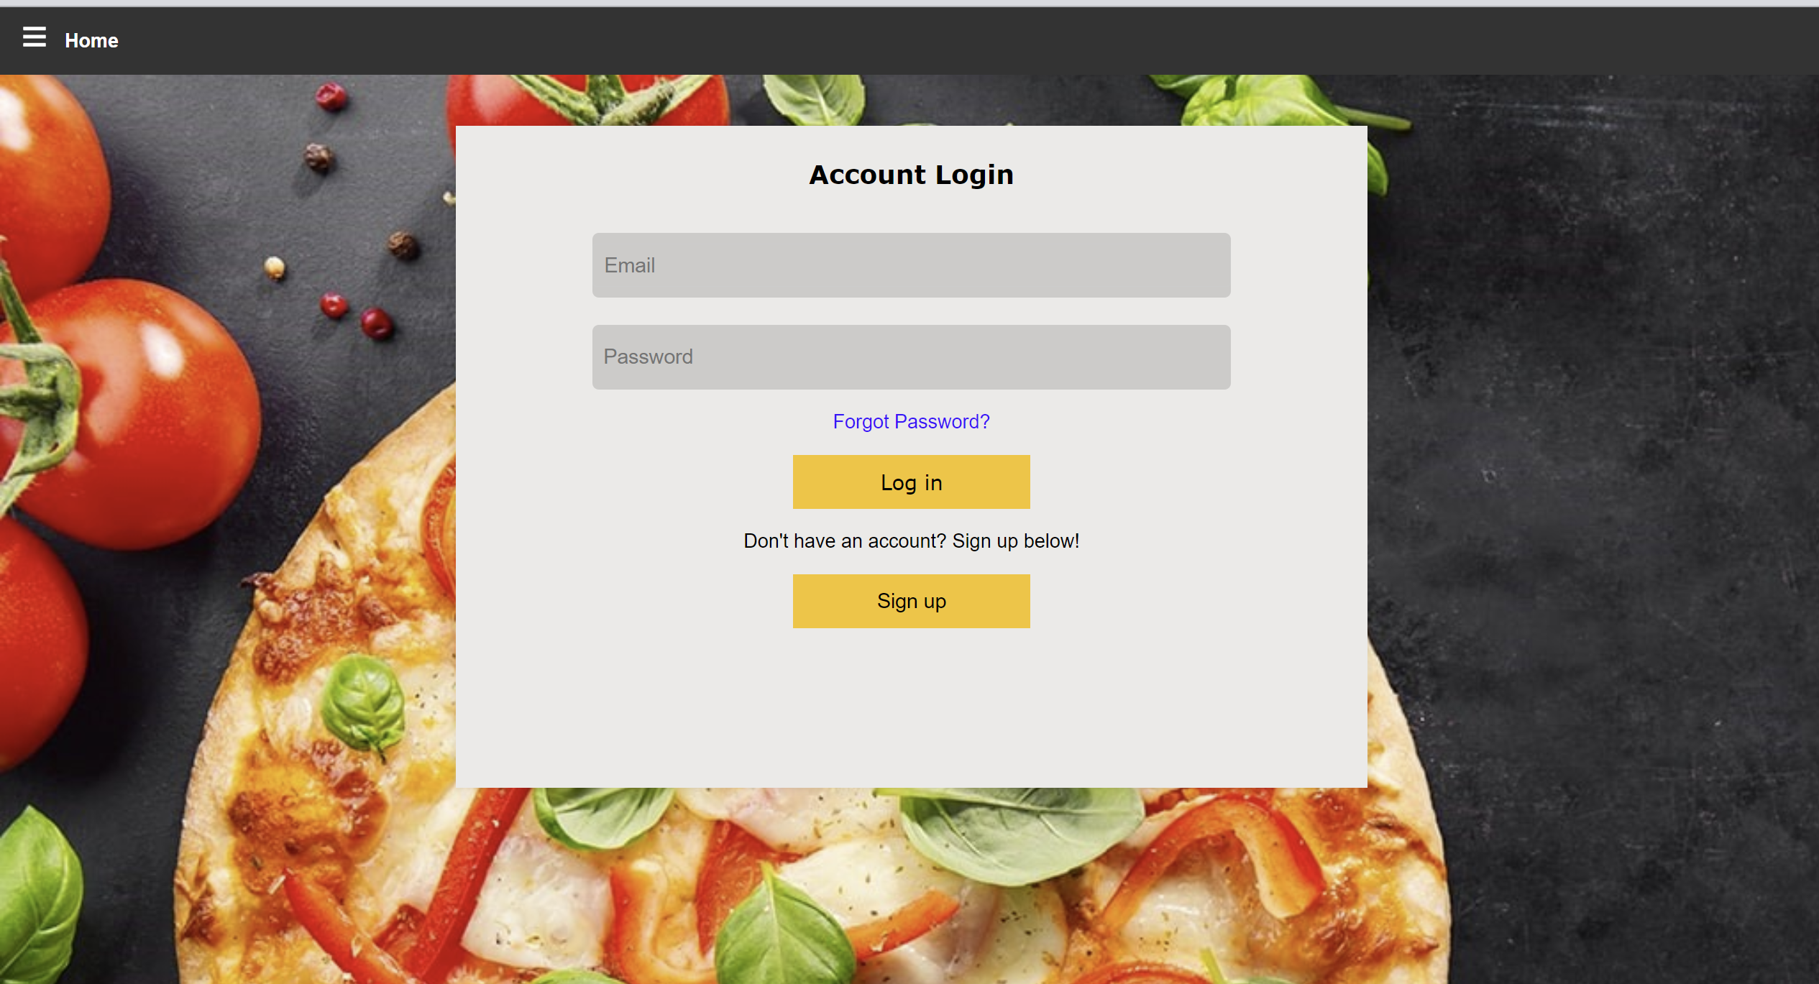

### 3.3.1 Accessing the Login Page

To access the login page, first you must open the sidebar menu with the three lines next to the Home button. Then you can select the Account page. This will bring you to the login page.   
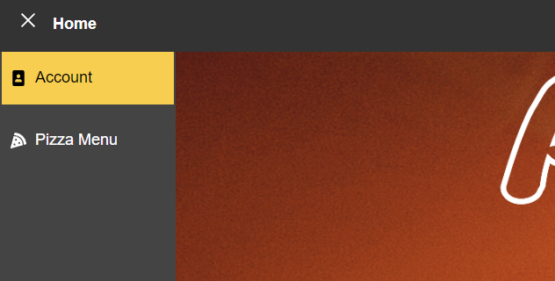

## **3.4 User Profile**

Users can update their profile from the profile page.

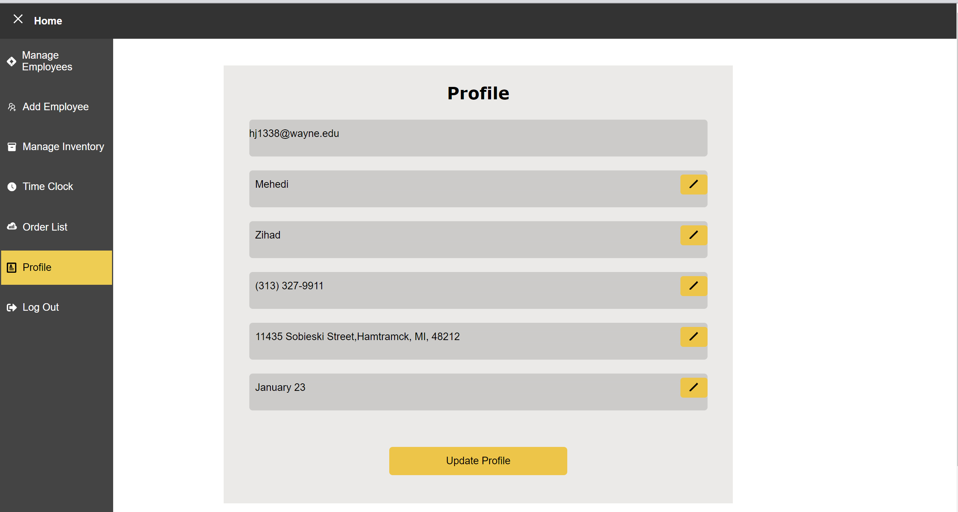

### 3.4.1 Editing Profile Information

## **3.5 Forgot Password**

If you forget your password, you can rest this password by clicking on “Forgot Password?”

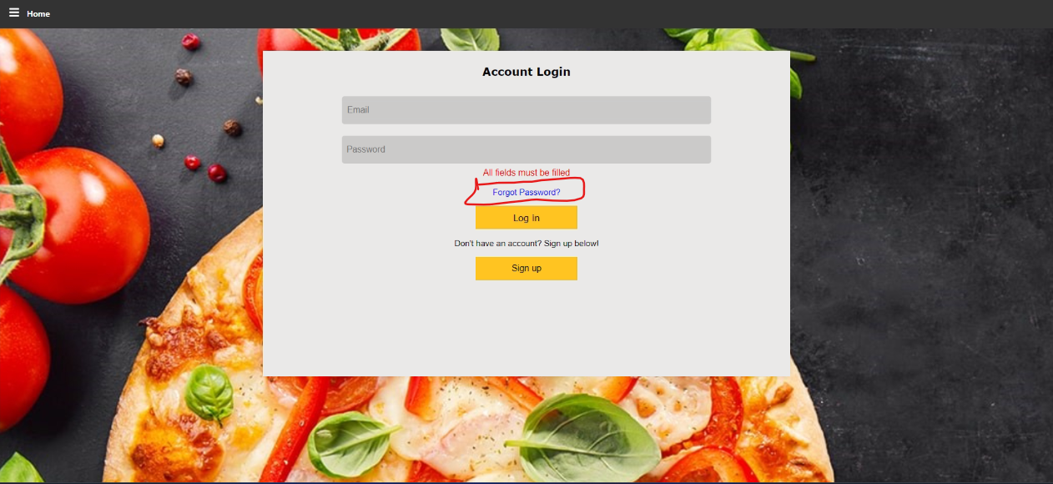

After click on the “Forgot Password?” linked to the following page

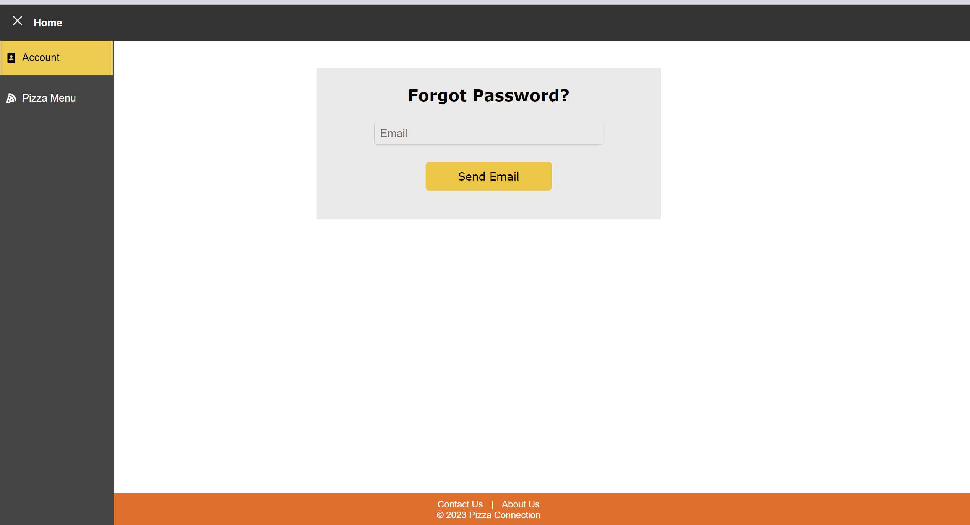

### 3.5.1 Account Recovery Process

Then enter your email and click the send email button

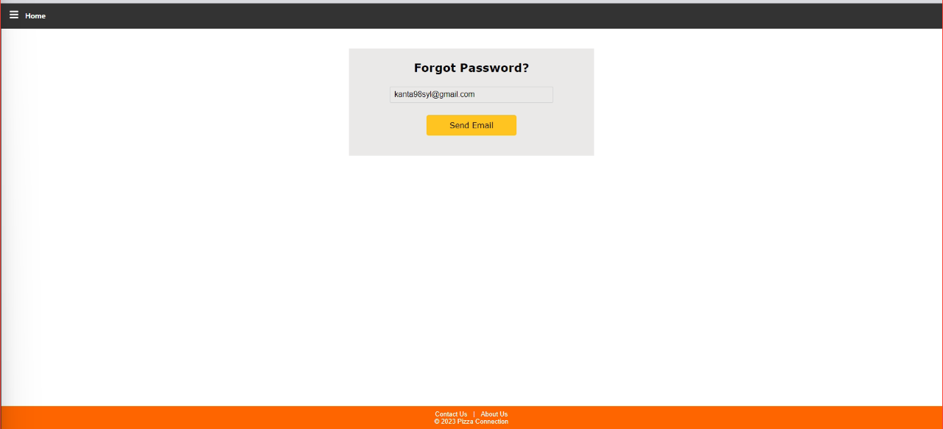

You will receive the reset password email verification

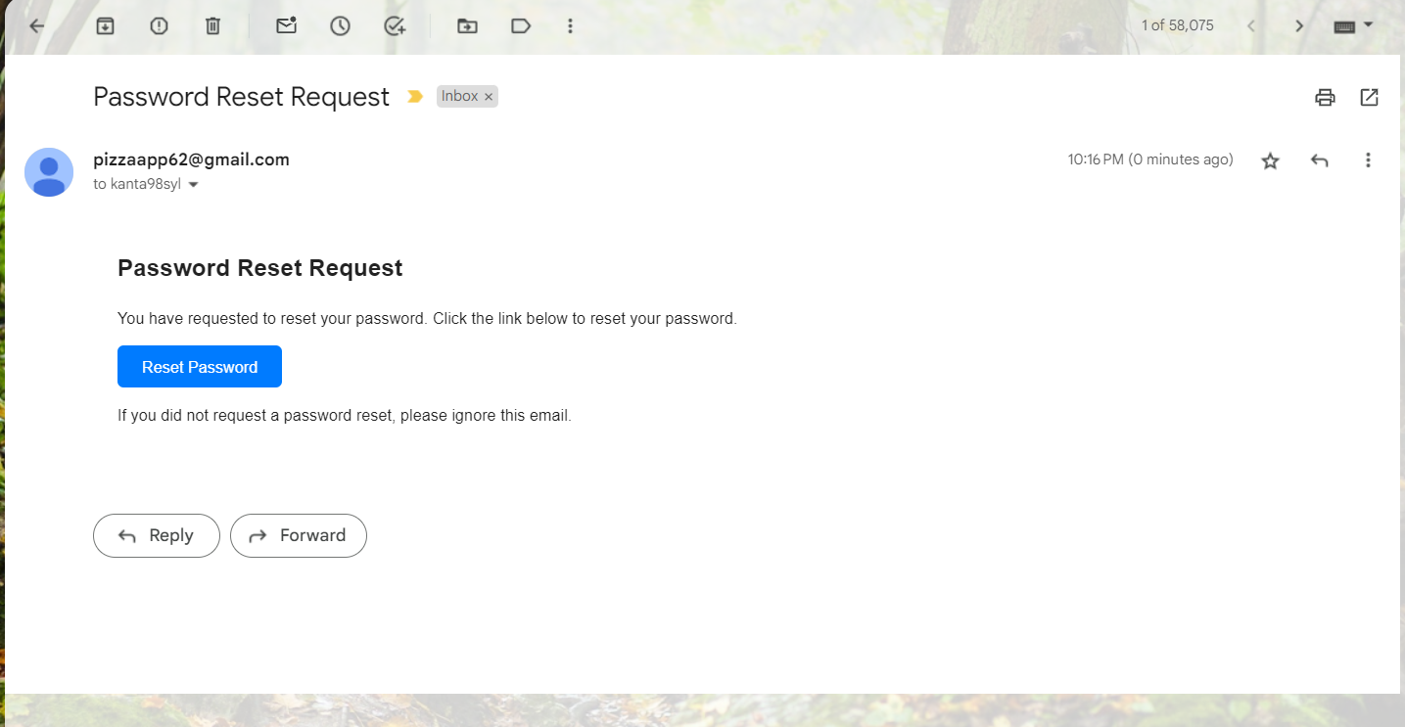

### 3.5.2 Resetting Password

After clicking the “reset password “ link you will get following page

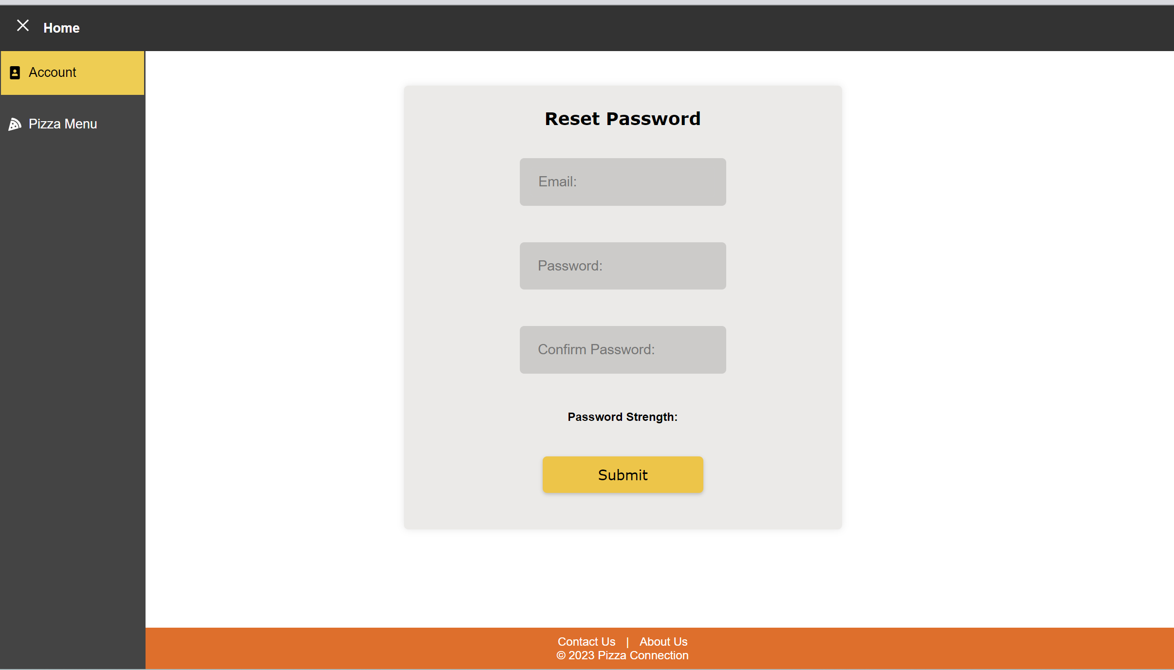

## **3.6 Add Employees**

Admin users can add employee on the system by inputting following information.

After adding new employees successful message will show up.

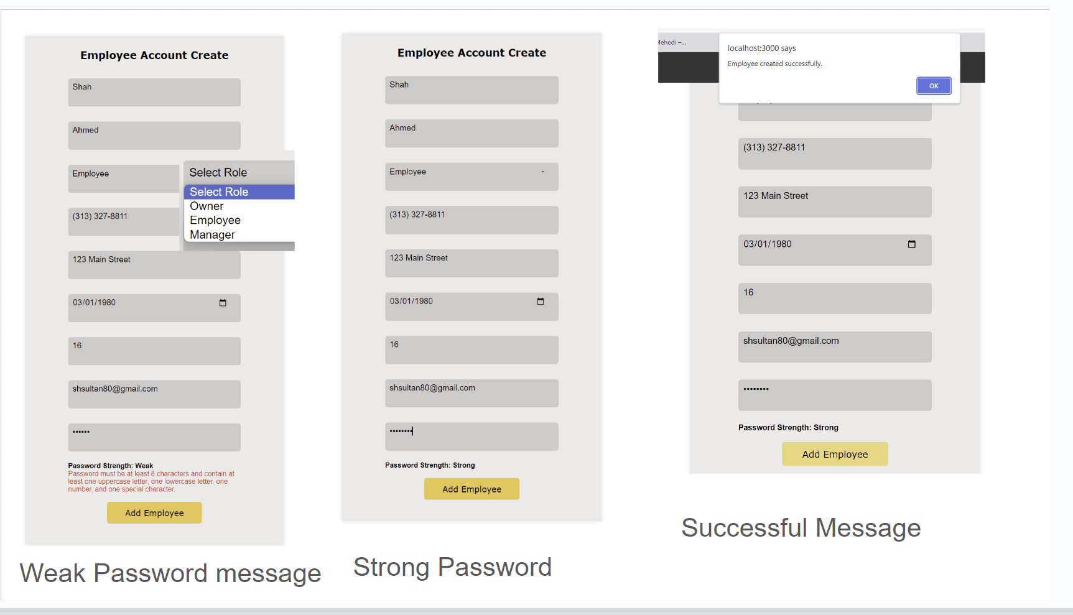

## **3.7 Manage Employees**

1. In Manage Employees page admin can manage the time sheet, Edit the Employee information, and they can also delete the employee.

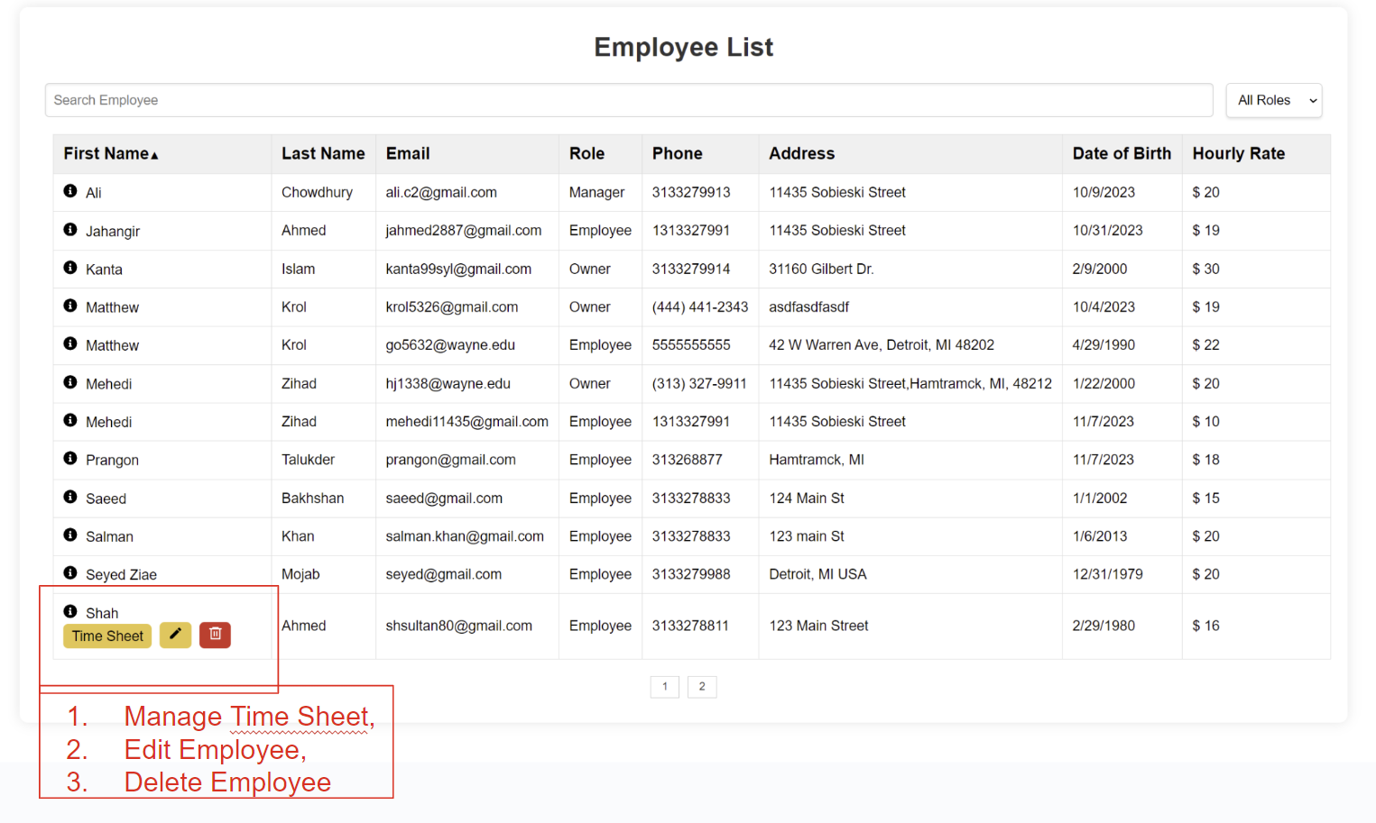

### 3.7.1. Edit Employee

Admin users can edit employee information on the system by inputting the following information. Here Admin user Shah Ahmed Role Employee to Manager. And after clicking Save button successful message will show up.

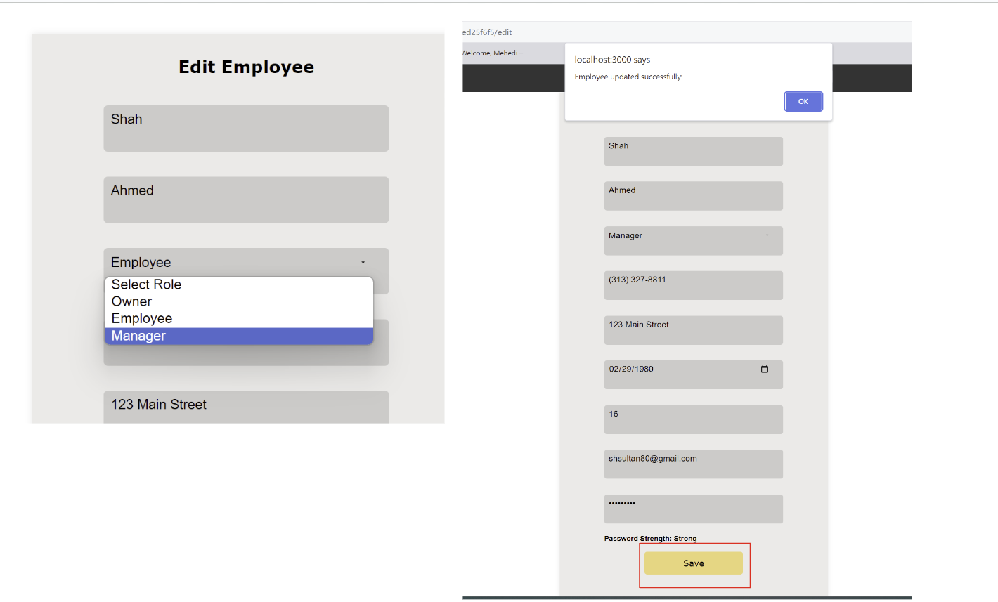

### 3.7.2 Search Employee

Admin can search for employees with their firstName and lastName.

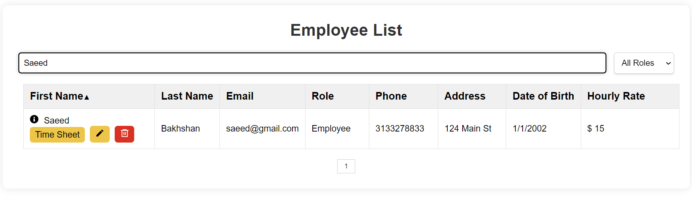

### 3.7.3 Filter by Roles

Admin can filter by their roles (Owner, Employee, Manager)

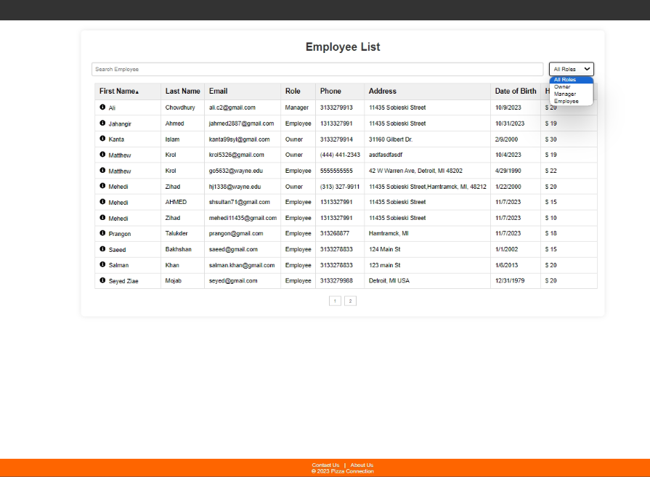

### 3.7.3 Delete Employee:

Admin users can Delete employee from the system. When They click on the delete button, System will ask “Are you sure you want to delete this employee”. If they Click OK, it will delete, otherwise it will go back manage employee page.

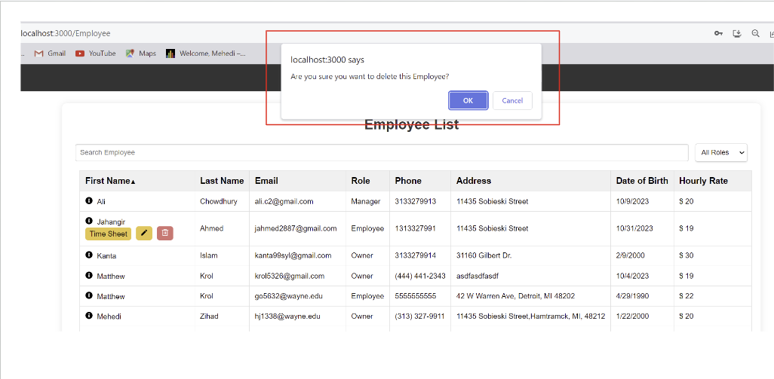

### 3.7.4 Time Sheet:

Admin users can access Time Sheet when They click on the “Time Sheet” button from Manage Employee page. Then System will redirect Time Sheet page, with Edit and Delete Time Clock options.

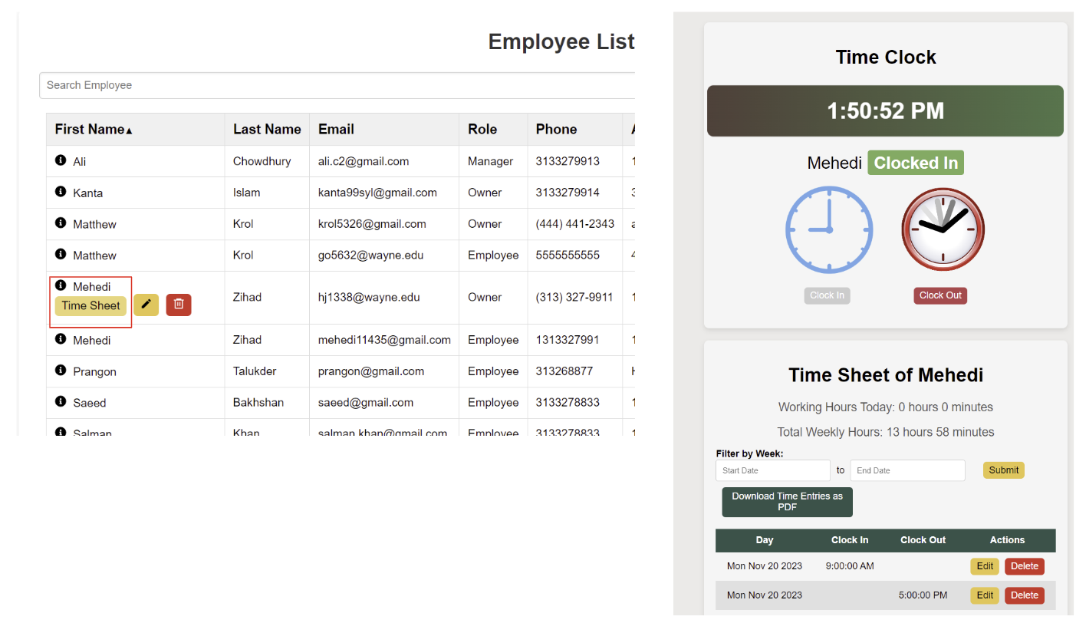

## **3.8 Employee Time Clock**

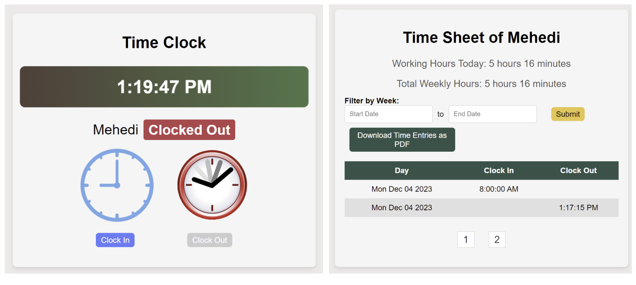

### 3.8.1 Clock In

### 3.8.2 Clock Out

### 3.8.3 Pay Period selection & Work Hours view

Pay period Selection Start date

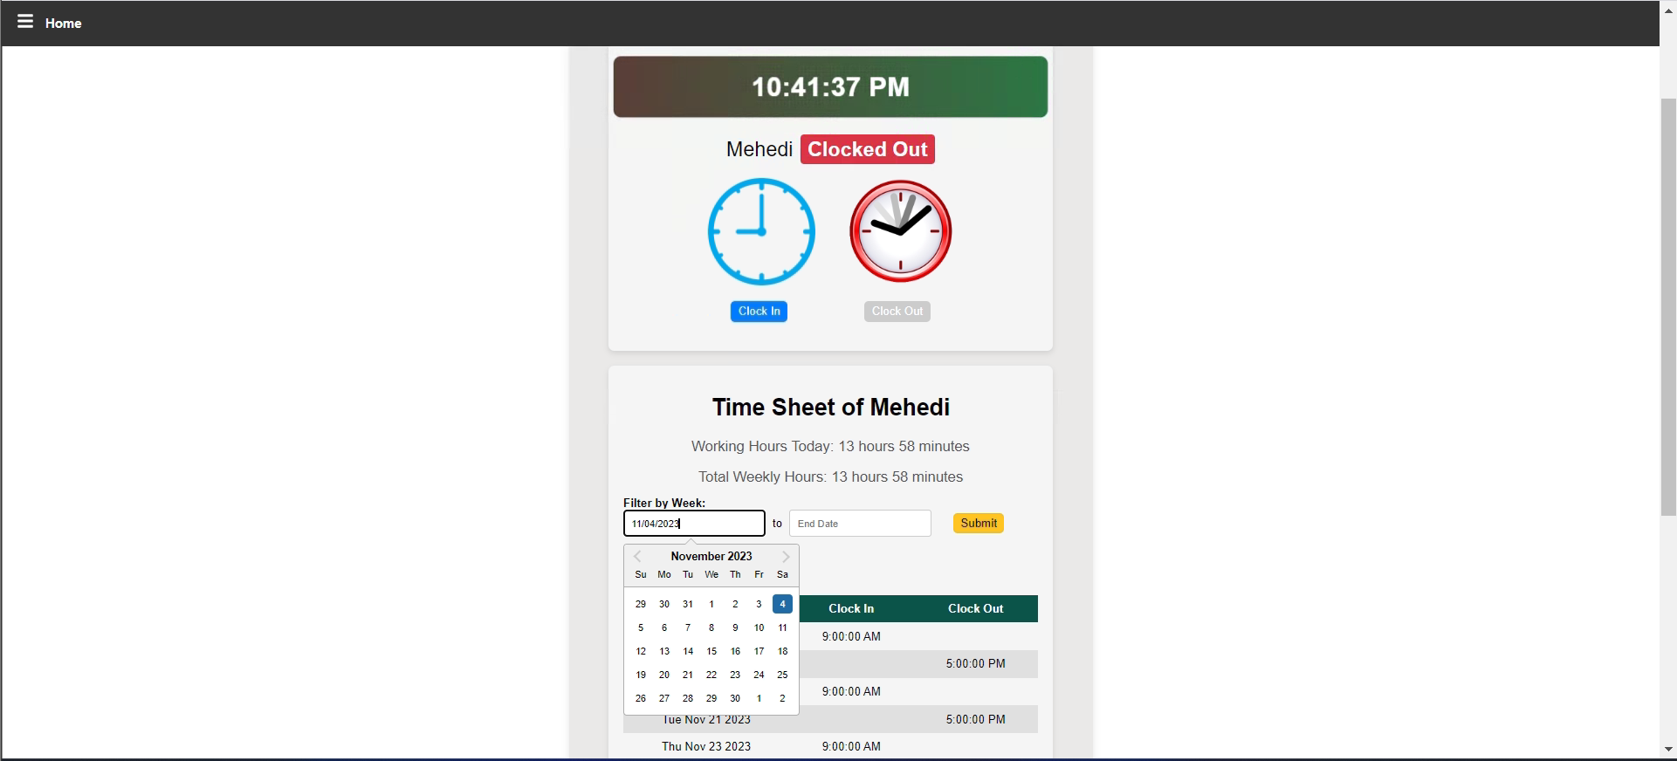

Pay period selection end date and click submit

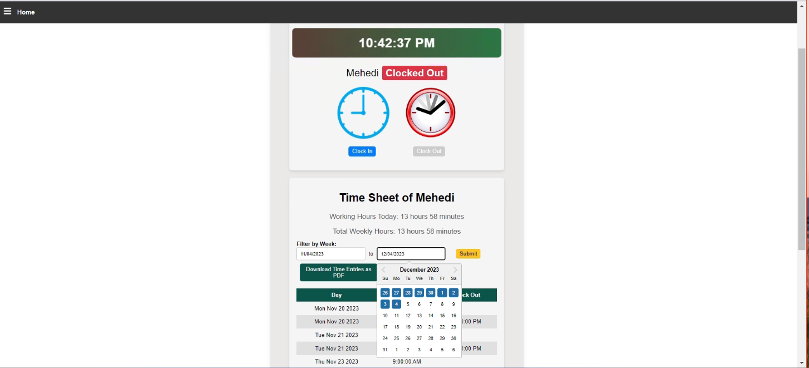

After clicking the “Submit” you will see the working hour's view

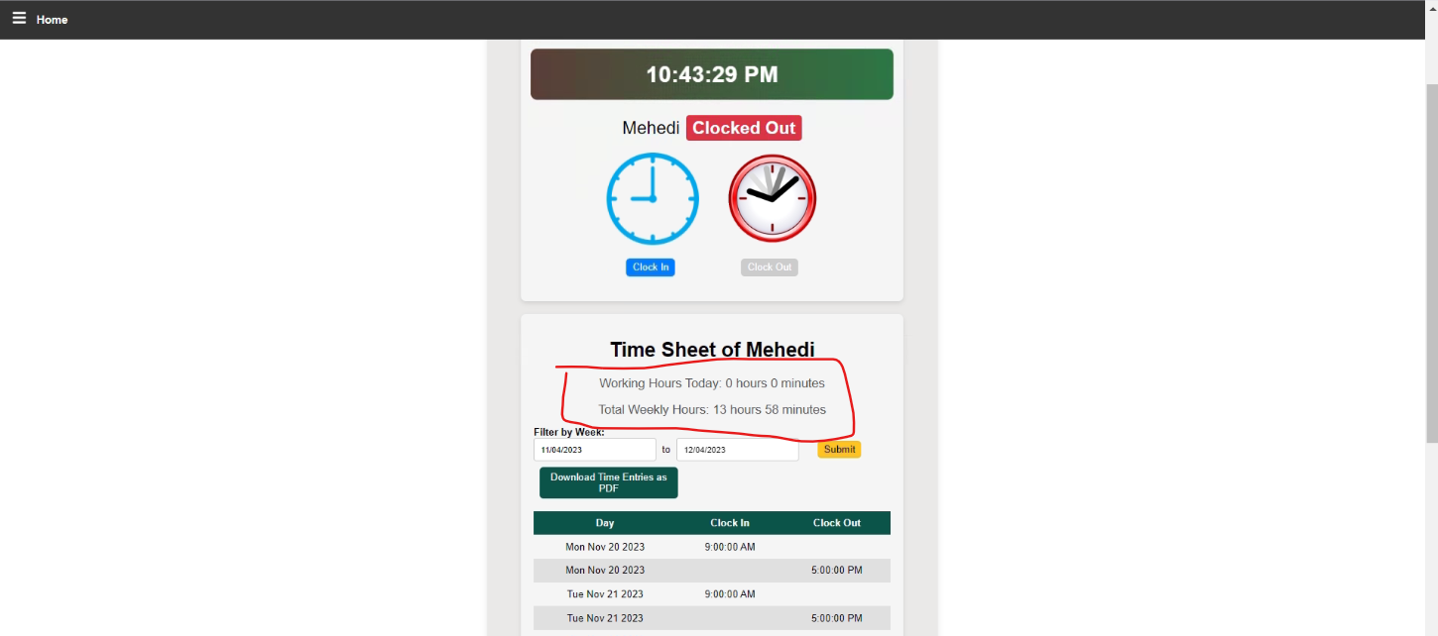

Then user can download time entries to see the full report of working hours as pdf format

Here is the working hours pdf file screenshot of pdf file

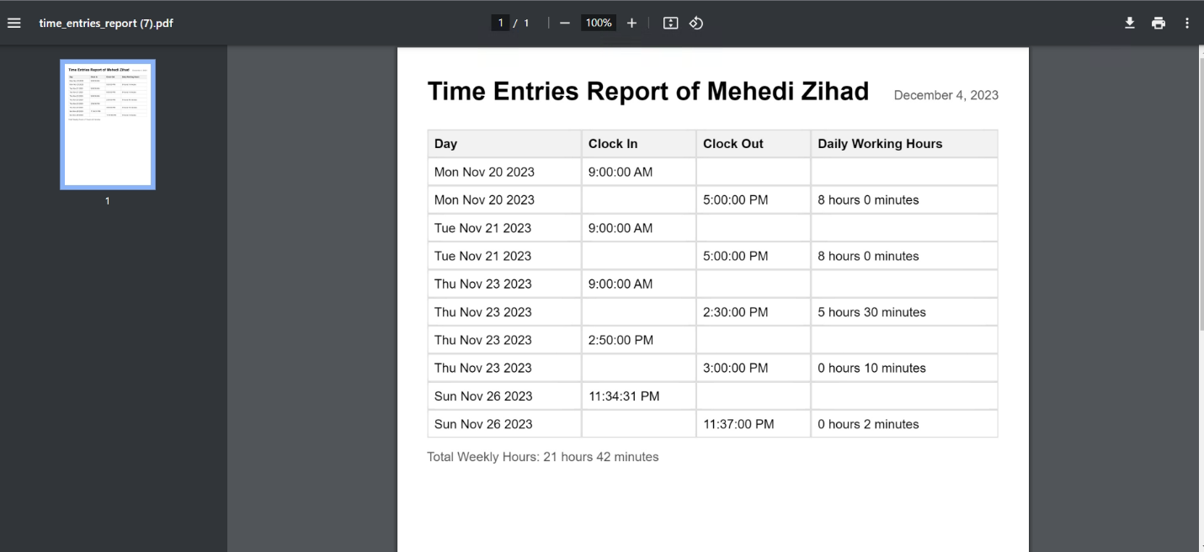

## **3.9 Time Sheet Management**

After redirected from manage employee page, Admin users can Edit and Delete Time Clock. They can also add “Clock In” Clock Out” on behalf of the Employee if they miss any time clock.

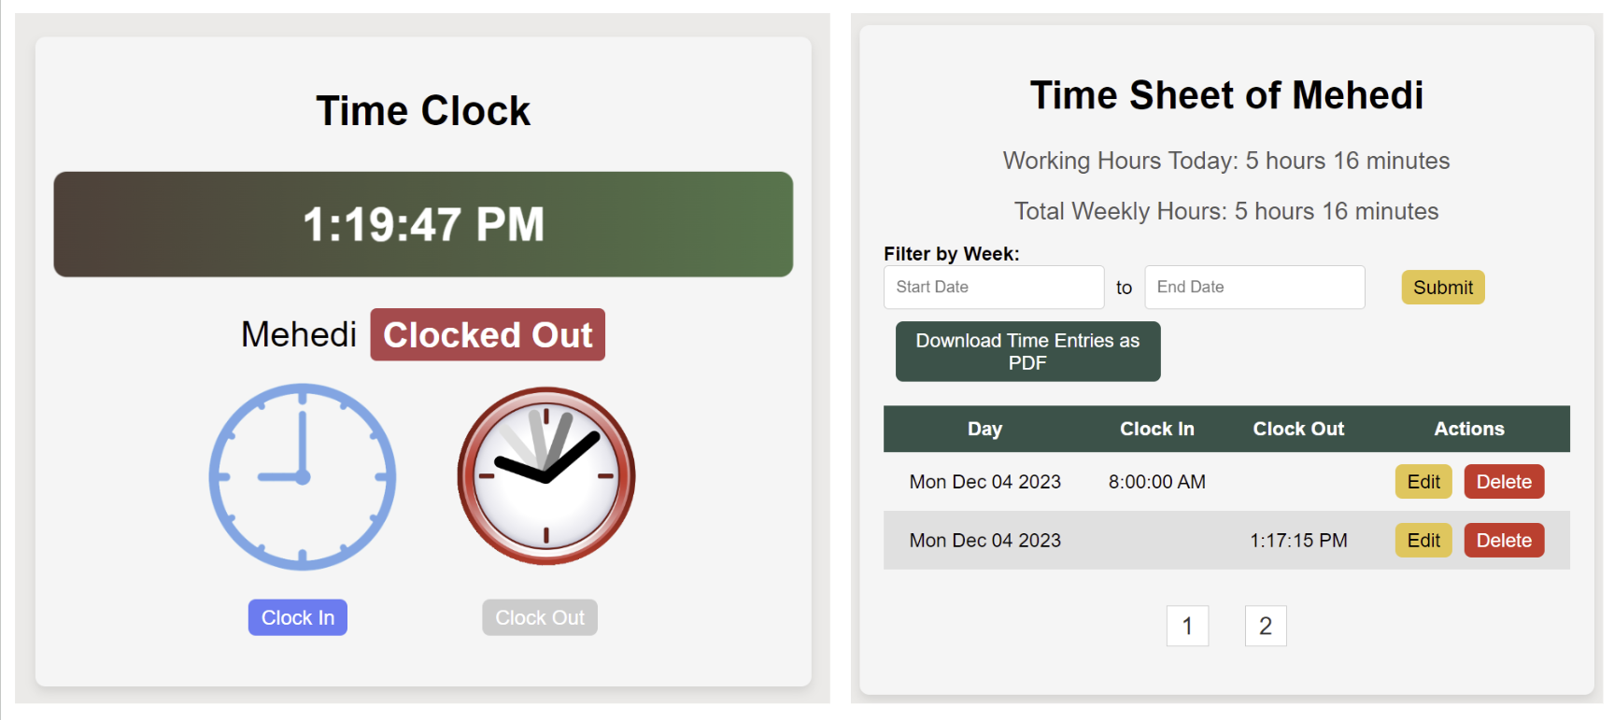

### 3.9.1 Edit Time Entry:

Admin users can edit the time entry of employee by clicking Edit button of the Time Sheet. After updating successful message will show up.

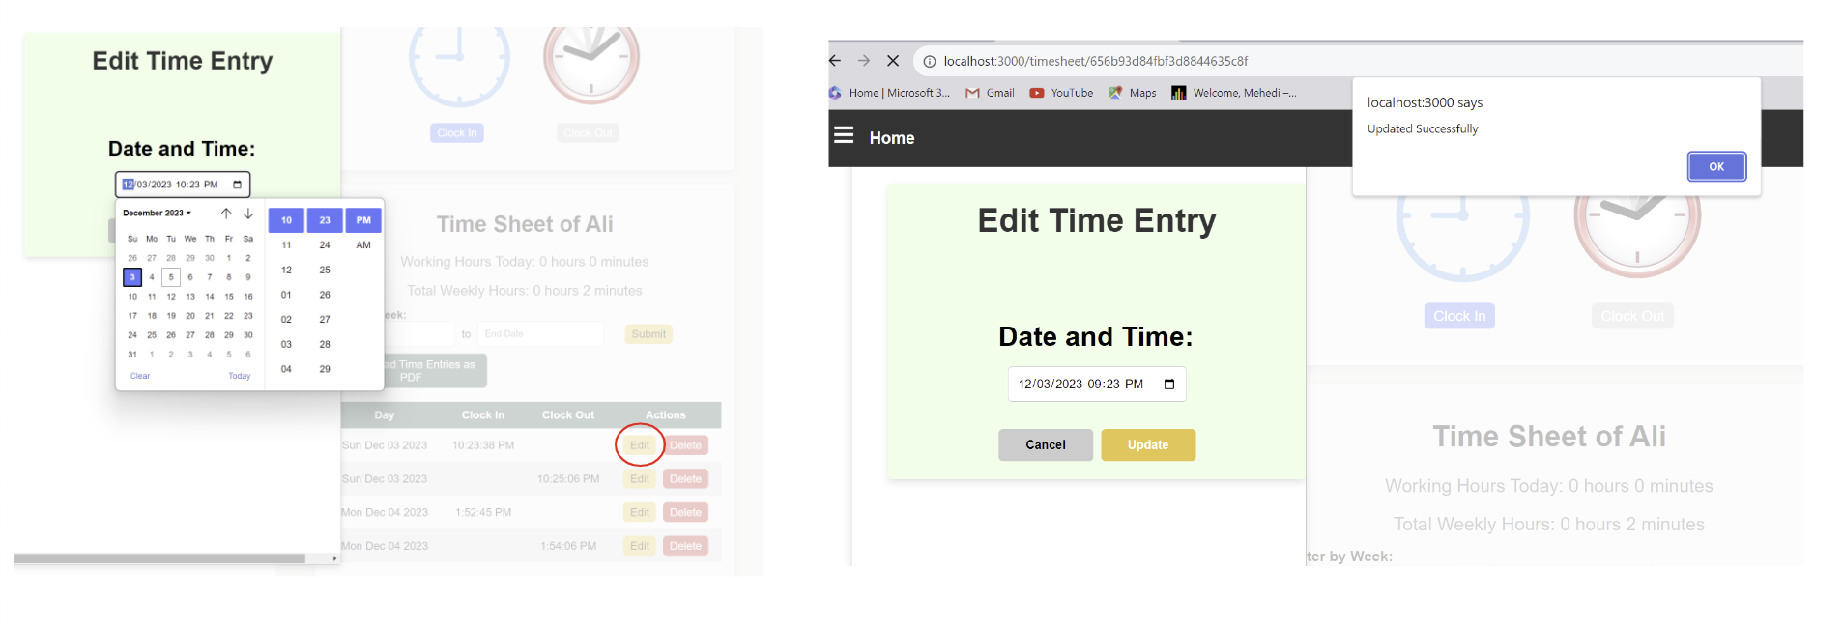

### 3.9.2 Delete Time Entry:

Admin users can edit the time entry of employee by clicking Delete button of the Time Sheet. After deleting time entry, a successful message will show up.

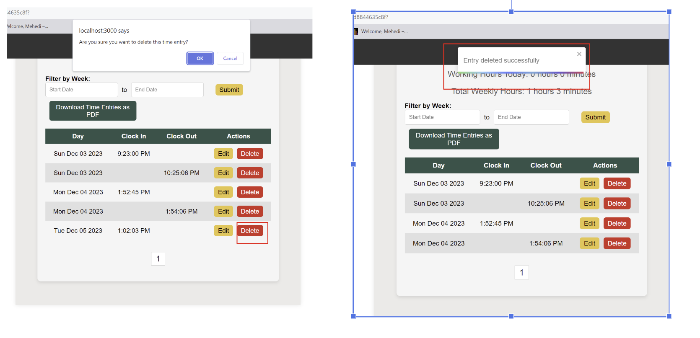

### 3.9.3 Filter by Week:

Admin users can also filter by weekly time entry of employee by selecting date, then pressing Submit button.

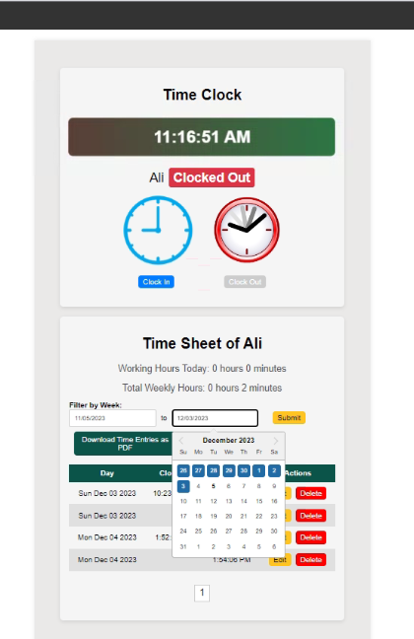

### 3.9.4 Download Filtered Weekly report:

Admin users can also download the weekly time entry of any employee.

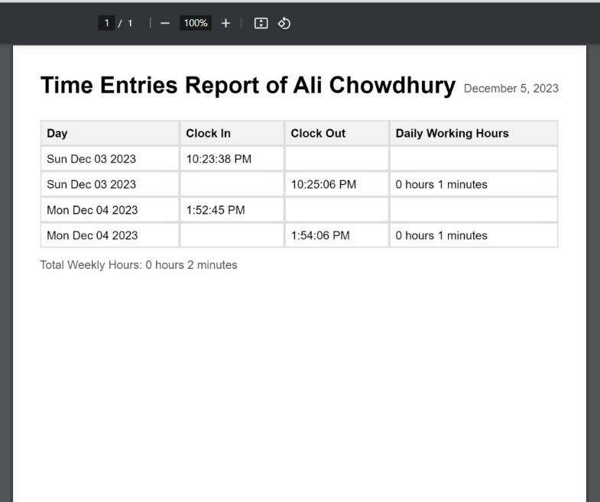

## **3.10 Pizza Menu**

To get to the pizza menu you must go through the sidebar by selecting the Pizza Menu button.

3.10.1 Browsing the Menu  
While on the pizza menu page, you can hover over the item you would like to select and select the customize button.   
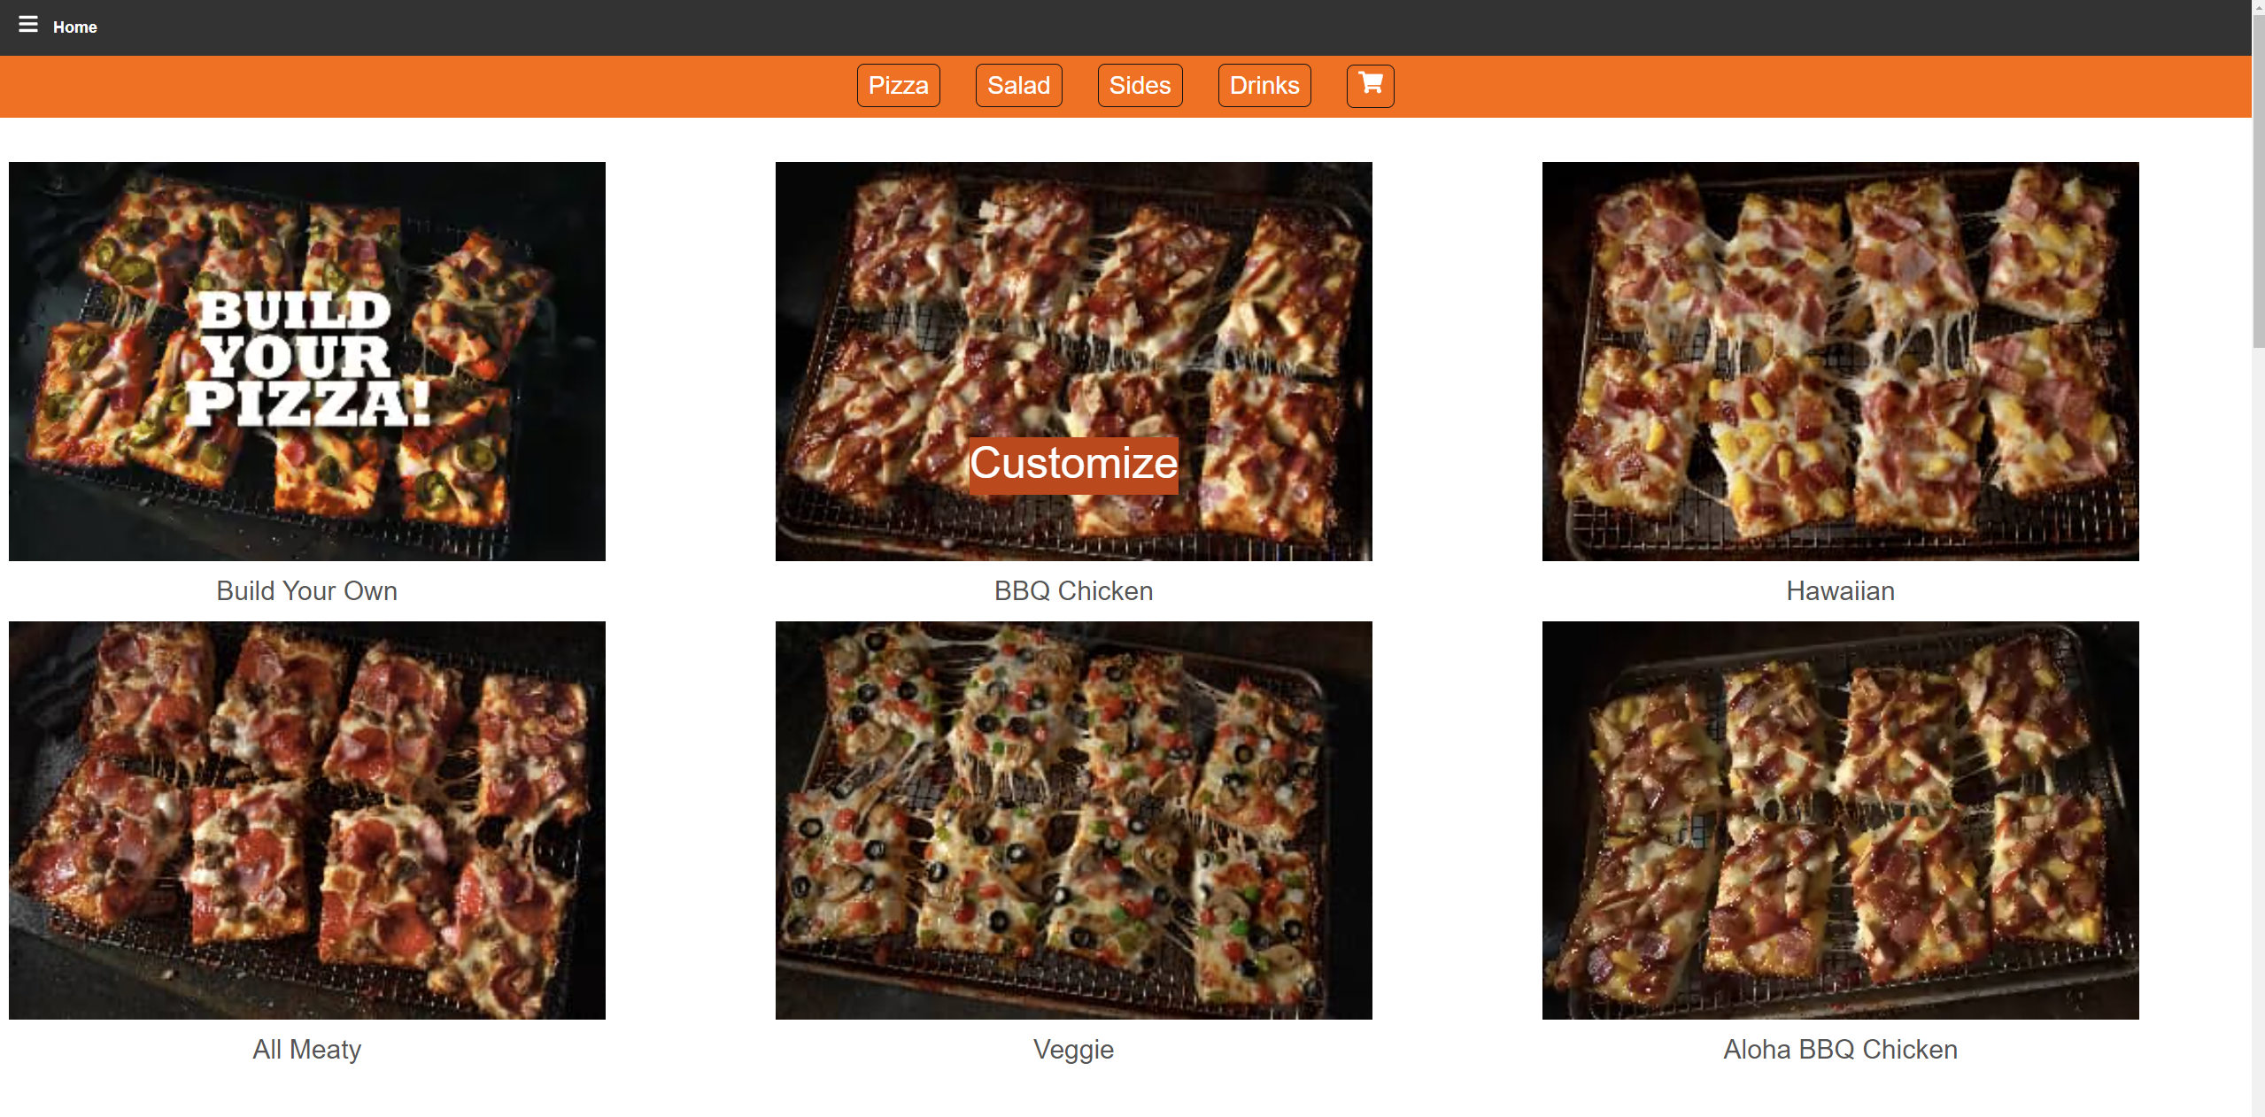

Otherwise, if there is no customize button you can only add the item to the cart.  
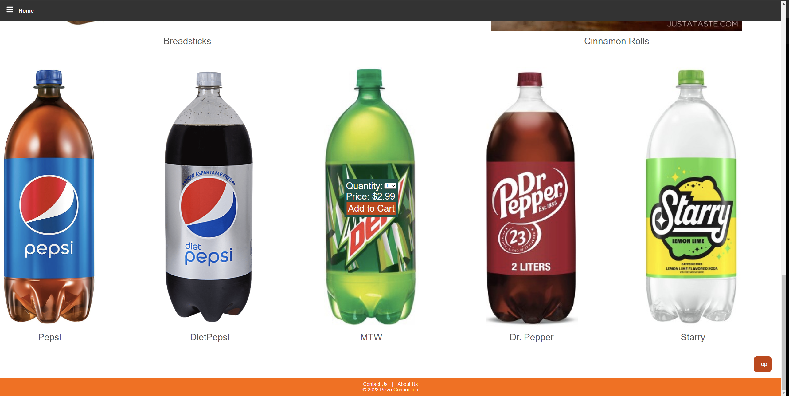

## **3.11 Order Cart**

To get to the order cart page, you would need to select the cart button on the top of the menu page.  
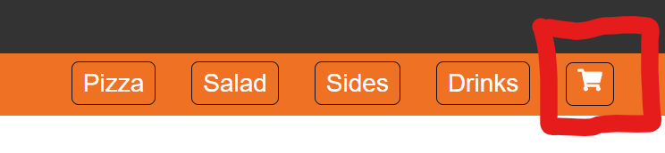

### 3.11.1 Managing Cart Contents

## You can also change some selection on items in the cart. To do this hit the edit button, and the changeable options will appear on the right side of the screen.

## **3.11.2 Place order**

To finish and place your order you need to hit the Place Order button on the right side of the screen.  
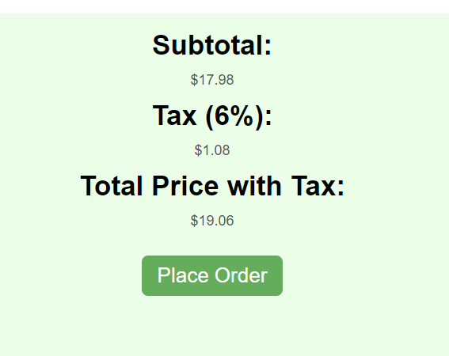  
This will lead you to a page where you can enter your payment details and finish the payment of the order.

## **3.12 Inventory**

### 3.12.1 Adding Inventory Items

To add an inventory item, fill out every field in the form displayed in the screenshot. Note for category it is a drop-down selection from which it will affect what unit types are displayed appropriate to that category. For quantity either type in a number or use the arrow buttons to the right to select a number to input.

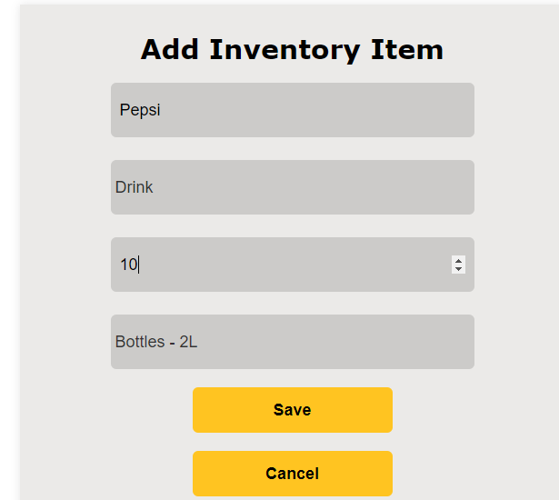

After clicking on the save button to submit the form you should see the following message appear above the save button in green text

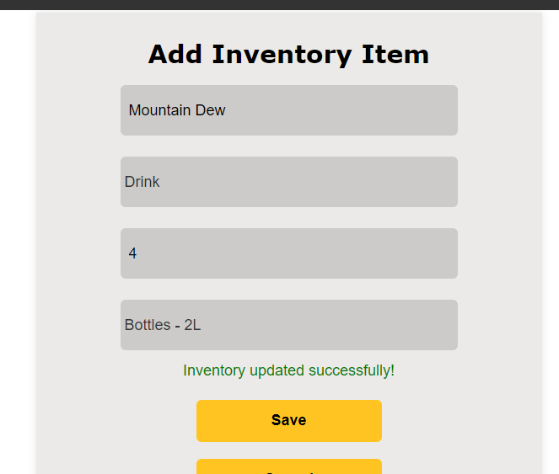

You may also cancel the form and return to the previous page by clicking on the cancel button.

An error message appears only if the item name you input is not unique or if no connection to the DB can be made. In this case reload the page to solve the connection problem or check your internet connection.

### 3.12.2 Inventory Editing

To edit any item in the inventory simply click on the edit inventory button and then click on any item in the list to bring up the input fields to modify each field.

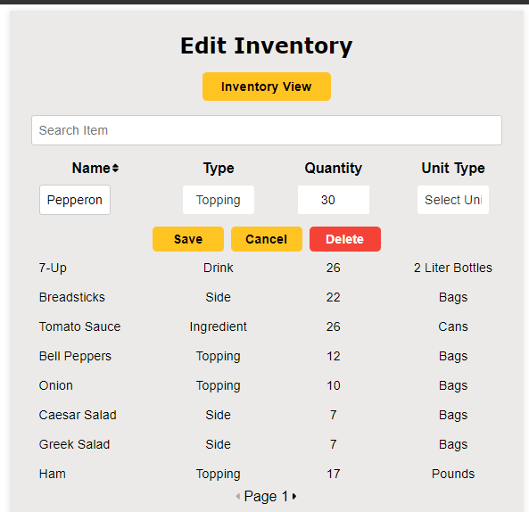

Clicking on that row will also bring up three buttons from which you can either save any changes made, cancel the changes/editing for that row or you can also delete that item from the inventory list. If you save your changes, you will see either one of two messages depending on if you made any changes or not: If changes were made then you will see a success message. If no changes were made, then you will see an error message. These messages pop up above the inventory view button.

Another thing to note is that when you initially click on the item to edit and you click on the dropdown for unit type no types will appear, so simply switch the category to something else and then back to display the available unit types for that category again.

### 3.12.3 Inventory Tracking

To add a tracking record for an inventory item, fill out the form like the example below. (it can be any that you need to add for whichever item in the inventory you would like to track and update its quantity for)  
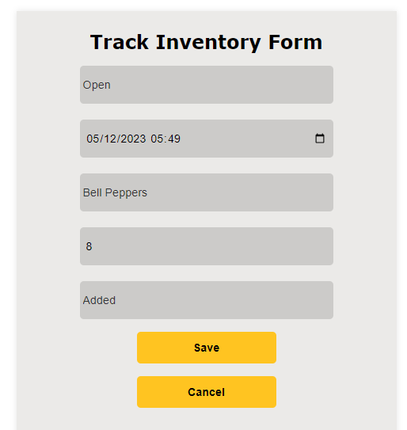

Once set, click on the save button to submit the form and add the tracking record for that inventory item. You can also cancel your changes by clicking on cancel which then will redirect you back to the track inventory page (save button also does the same redirect).

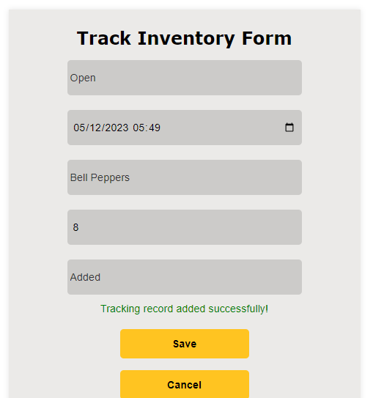

Upon successful submission you will see a message pop up above the save button and then you will be redirected back to the track inventory page. Keep in mind that if you attempt to use the Used-Up option instead for the last field and the quantity input brings down the total quantity of that inventory item below zero you will get an error as shown below.

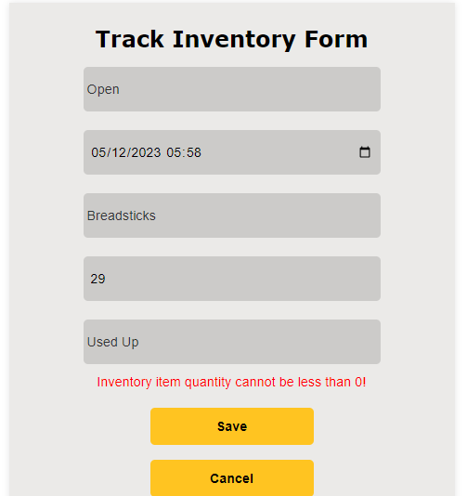

From this point forward you will have to click on cancel and then try adding a tracking record again, making sure that inventory item quantity is not brought down below zero.

In the tracking inventory page, you can click on any record/row to make the delete button show up (as well as the cancel) if you do not wish to delete that item then click on cancel to make the buttons go away. Otherwise click on delete if you wish to delete that record.

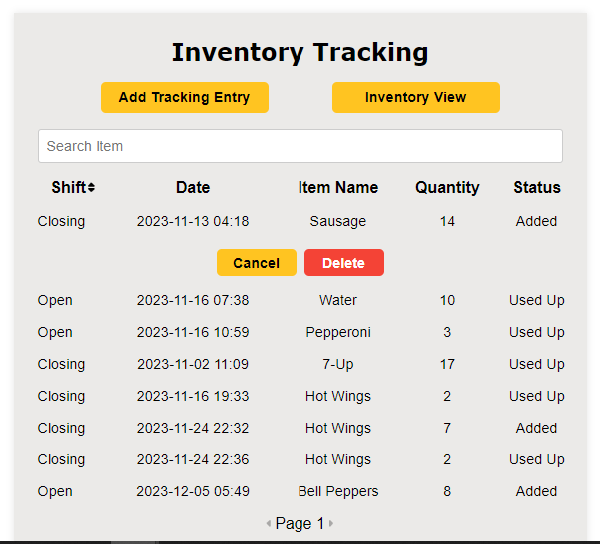

## **3.13 Payment**

For payment after the user clicks on place order, they are redirected to the stripe payment portal. Here the user may enter their information (since this site is not live nor is it connected to any real business; we are using the test API connection therefore no real payment information is utilized). Enter 4242 4242 4242 4242 for the credit card number, for expiry date and CVV fields you may enter any date (in the future) you wish and any three digits for the CVV field as this is a test connection with a test card number and will accept any expiry date (in the future) and CVV number combination. You may also enter any name for the card holder’s name field.

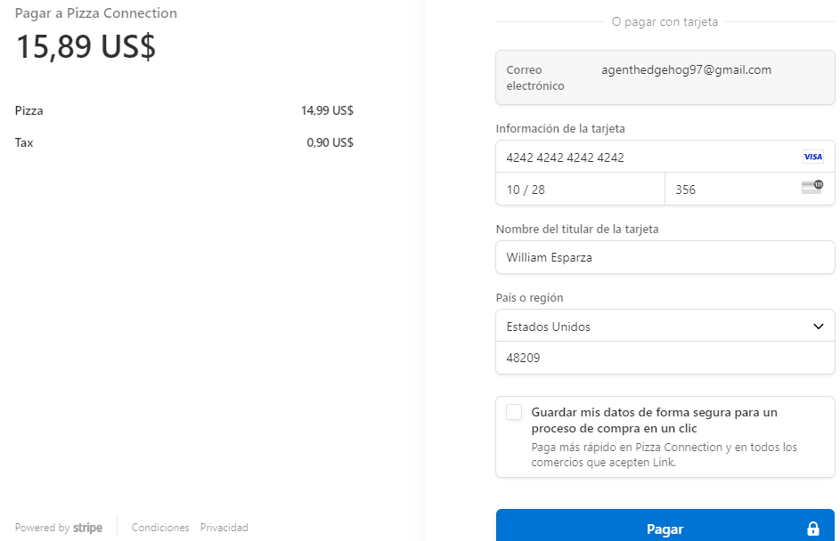

As seen in the screenshot the email registered to your pizza connection account appears here already as well as the subtotal and total and what items in the cart you selected. Once set click on pay (my browser’s settings are in Spanish so where it says ‘Pagar’ which is pay, you click on that button and the payment will be processed by stripe. If successful you will see the blue bar turn green.

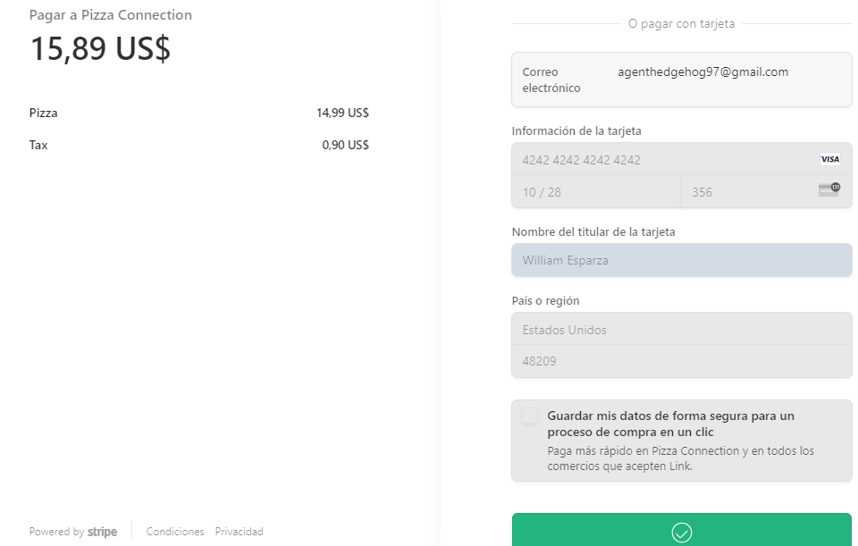

After the payment is processed the order is placed and saved in our database and system and them you are redirected to the order confirmation page which lists what you ordered, your details, date and total price paid for the order.

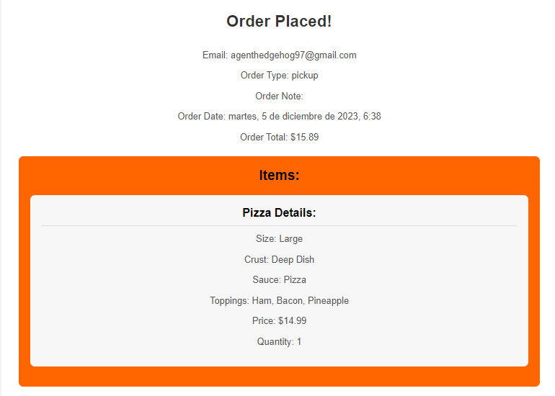

## **3.14 Order List**

After placing the order Admin/employee can see the order list page.

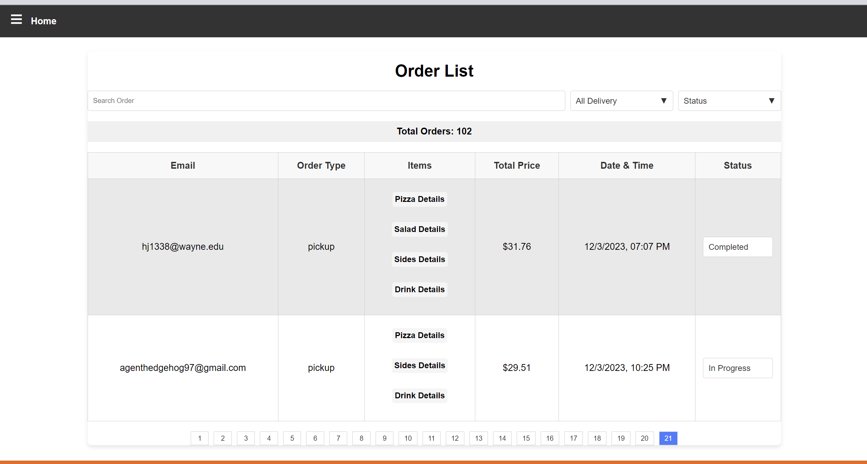

### 3.14.1 Search Order:

Admin user can search order by customer email address:

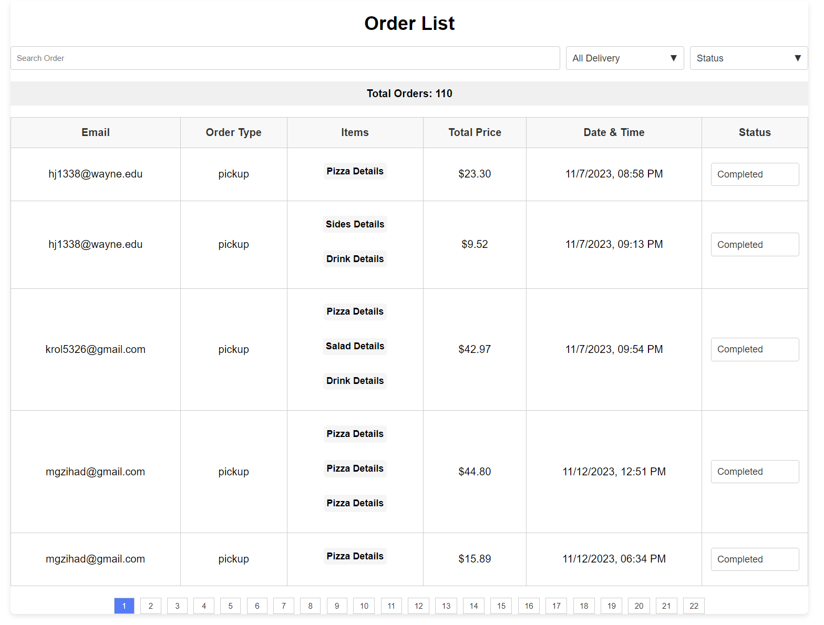

### 3.14.2 Filter order:

Admin users can filter the order by pick up or delivery.

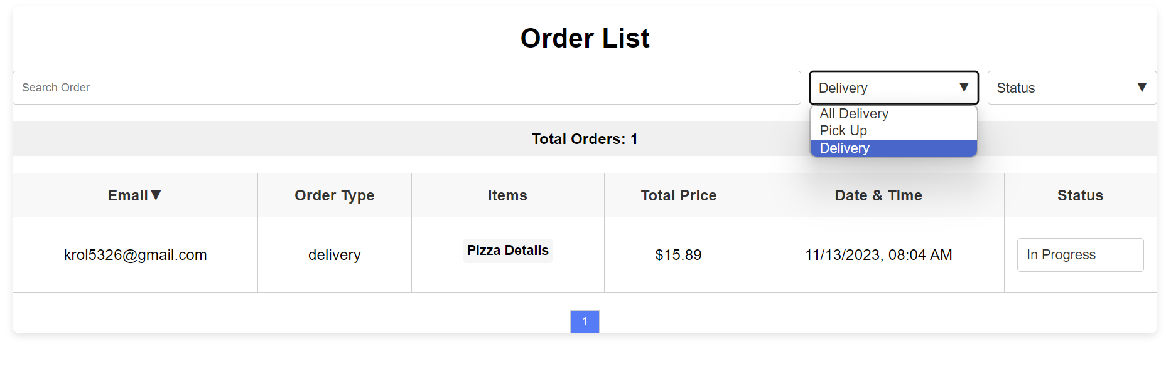

### 3.14.3 Filter Order Status:

Admin users can Filter Order Status by “In progress” or “completed.”

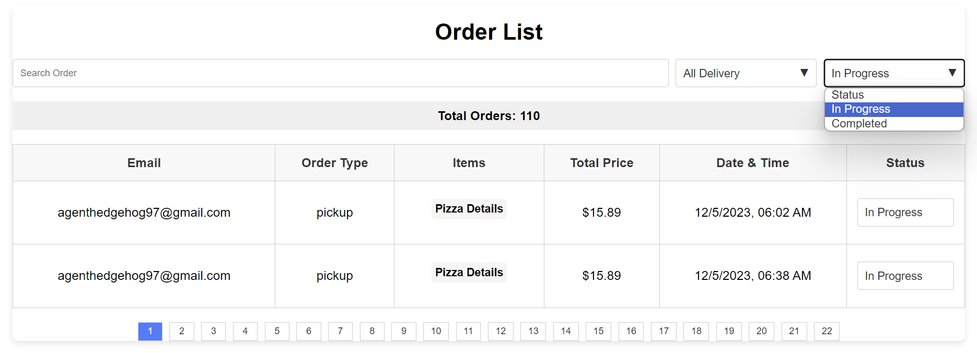

### 3.14.4 Sorting Email:

Admin users can Sort order list as email by clicking right of the Email Arrow.

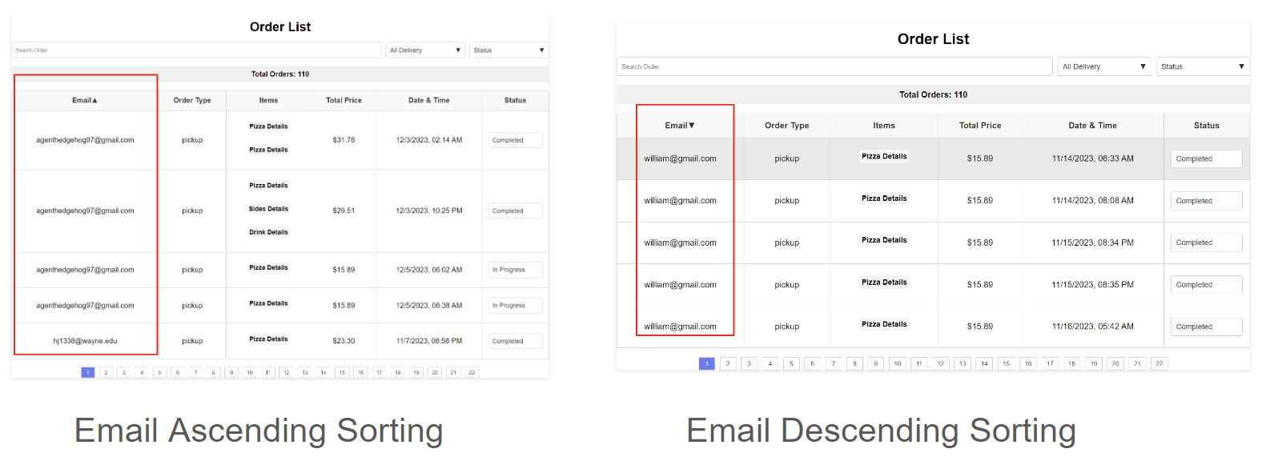

### 3.14.5 Sorting Date & Time:

Admin users can Sort order list as Date & Time by clicking right of the Date & Time Arrow.

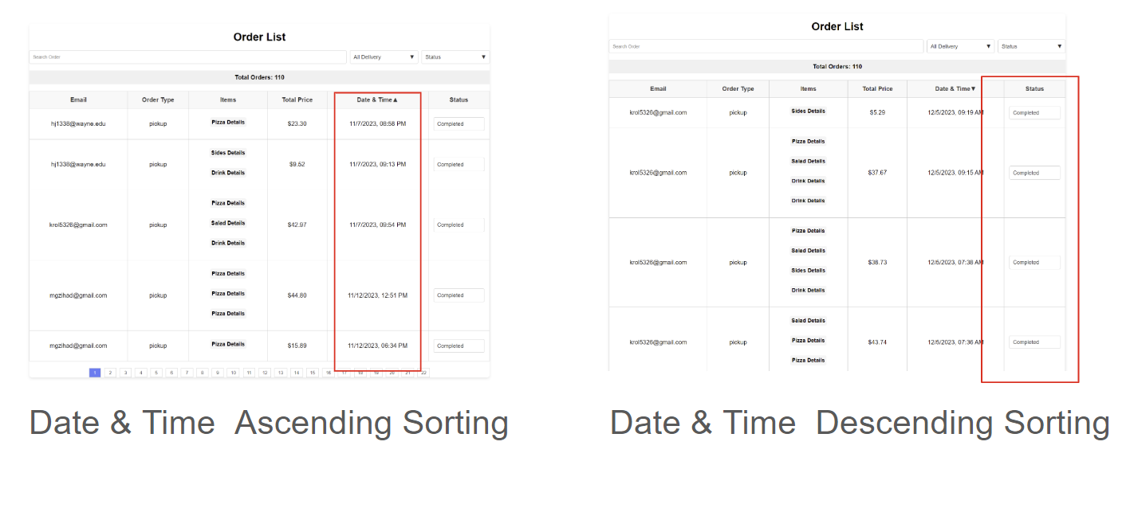

### 3.14.6 Sorting Date & Time:

Admin Users can Update

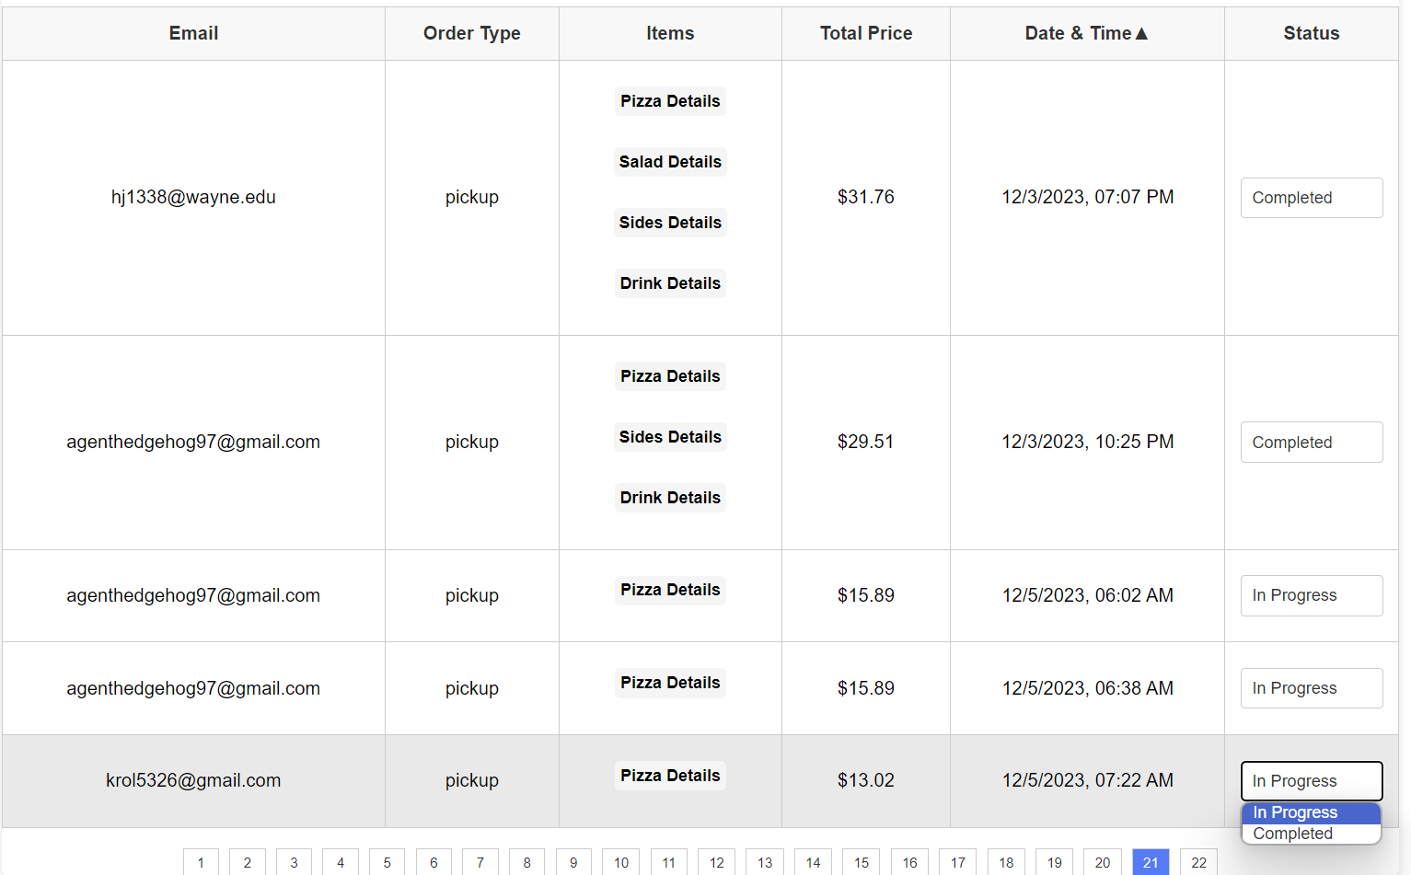

### 3.14.7 Display Items Details:

Admin users can display items details by clicking Order items in the column. Here after clicking pizza details, it displays all info of pizza order.

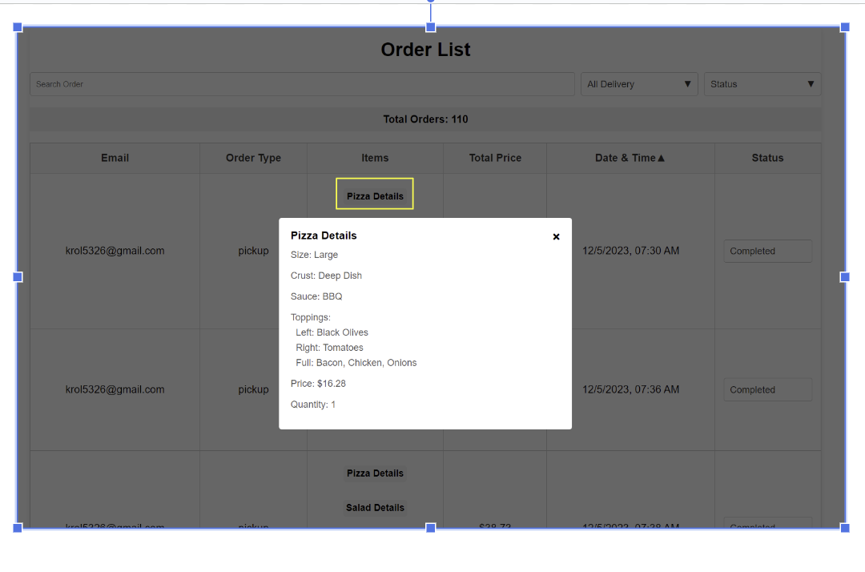

## **3.15 Contact Us**

To let us know any issues you can send message by submitting the contact us form , we will receive your message via email .

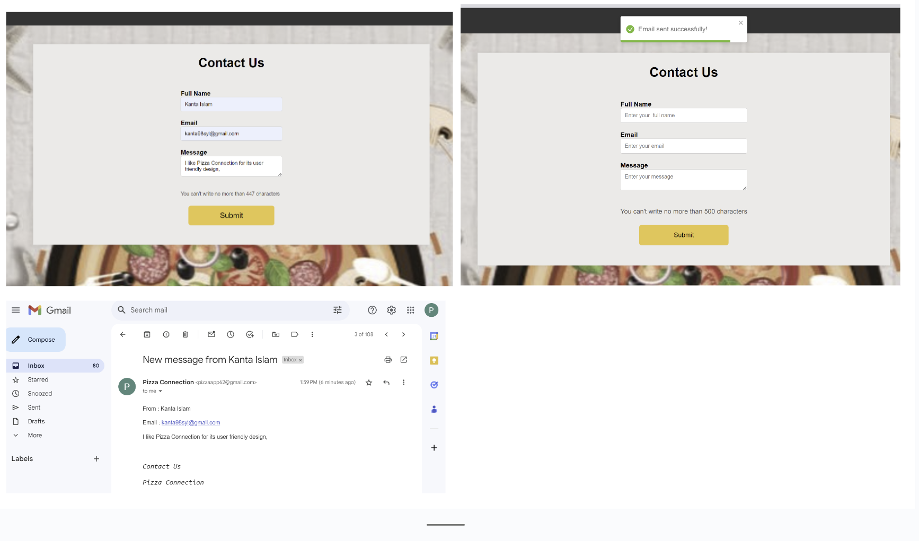

## **3.16 About Us**

To know about our web application and team you can browse about us page

